M80 Panel Type Thermal Printer

**Product specifications**

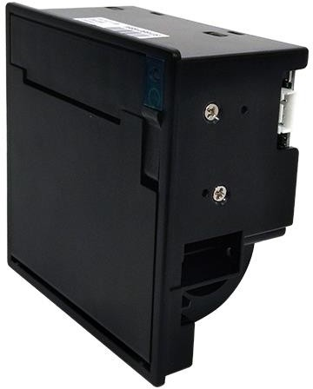

**Instructions for Printer Use**

**Before using the printer, read the following notes carefully：**

**Safety Precautions**

1. No current or voltage shall be applied to any pin in excess of the maximum absolute rating. If such current or voltage is applied in excess of the maximum absolute rating, the current flowing through the equipment may cause thermal damage.
2. Any output pin shall not be short-circuited by the power supply.
3. Conductive material falling onto the circuit board can cause a short circuit in the circuit board's pins, causing excessive current and heat damage.

* Ensure that the specified cable is used to connect the equipment.
* Incorrect connection may cause fire.
* Do not disassemble or modify the product.

**Precautions For Use**

1. Use the qualified printing paper provided or confirmed by the supplier, otherwise it may affect the printing quality and the life of the printing head, or even damage the printing head.
2. The width of the printing paper roll, the minimum diameter of the inside diameter and the maximum diameter of the outside diameter should meet the error requirements. Otherwise it may appear that the paper is not smooth, straight, and other phenomena affect the normal work of the printer.
3. At any time, hard objects (such as tweezers, blades, etc.) shall not be used to remove the paper scraps or other attached crops in the cutting edge or on the head piece, so as to avoid permanent damage to the head piece or blade.
4. Do not plug or unplug the signal interface cable while the printer is powered on.
5. After printing, if the machine head is opened, do not immediately touch the print head or motor shell by hand, so as to avoid being scalded by the metal shell.
6. 4.The friction between the roller and the thermal paper is very high. When there is no paper in the printing head, avoid paper running at this time, and it can not be printed, otherwise it is easy to damage the thermal sheet. When the cover of the paper bin is opened, do not print, otherwise it will damage the heat sensitive film.
7. The print head should be cleaned regularly (with anhydrous alcohol) to ensure the print quality and service life.
8. If the printer is working outside, pay attention to the regular dust cleaning of the printer to avoid the sensor cannot accurately and effectively report the status of the printer due to dust coverage.

**Precautions for transportation and storage**

1. Ensure that the equipment is placed on a firm and stable horizontal surface.
2. When transporting the printer, it is necessary to use foam, foam bags and other packaging.
3. If the equipment falls, it may be damaged or suffer other injuries.
4. Excessive moisture and dust may damage the equipment.
5. Do not place heavy items on the product. Never stand on or lean on the product.
6. Equipment may fall or collapse, causing damage and possible damage.
7. To ensure safety, please unplug the product when not in use for a period of time.
8. If you do not use the printer for a long time, please replace the paper and restart the printer.

**Panel type thermal printer**

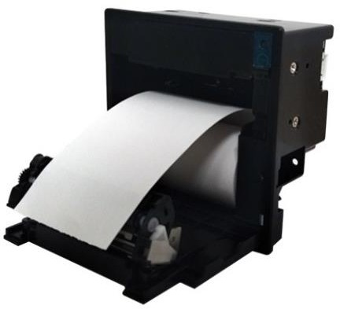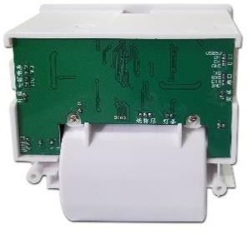

**M80**

# The structural design is easy to add paper. Easy to maintain, stable and has reliable quality.

# It has the function of paper output detection or light prompt.

Fast printing speed, even in graphic mode can provide 200mm/s printing speed.

Mature application development under Windows and Android system, providing SDK.

**Standard with automatic paper cutter**

**（****Semi-cut Space** **in the middle） A variety of communication interfaces are available**

## Full-cut/Semi-cut Integration Standard serial port RS232(Support TTL customization)USB port

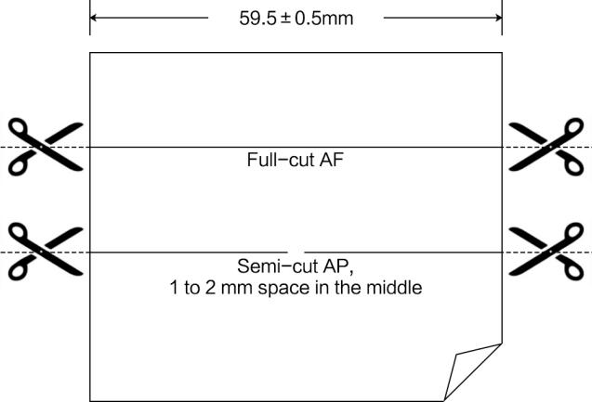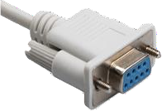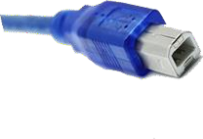

located in

Control through different commands

（It can also be selected under drive）

There are four baud rates to choose from：

9600bps 38400bps

19200bps 115200bps

# Flexible choice of paper for a variety of applications

## The printer can use thermal paper and thermal label paper（The paper thickness is within 0.12mm），The maximum outside diameter of the roll is 50mm；Support the location of black mark on the right side of the front；

Thermal paper，Paper width 80mm，

inner diameter 10mm，external diameter 50mm Thermal label paper，Paper width 80mm，

inner diameter 10mm，external diameter 50mm

# The driver can be installed under WINDOWS

**Provide SDK to support users to develop applications under WINDOWS and Android**

**A variety of bar code format printing**

 

QR PDF 417

Available in white and black

**Basic technical parameters**

|  |  |
| --- | --- |
| Model | **M80** |
| Printing method | Line thermal printing |
| Resolution ratio | 203dpi |
| Printing Speed | 150mm/s (max), adjustable |
| Printing Width | 384dots (48mm) |
| Paper width | 57.5±0.5mm/79.5±0.5mm |
| Thickness | 56T05 um |
| Feed paper method | Easy to feed paper |
| Cut paper method | Full-cut/Semi-cut |
| Print Length | 100km |
| Cutter life | 1 million times |
| Character | FONTA 12*24 dots |
| FONTB | 9*17 dots |
| GB18030 Simplified Chinese | 24*24 dots |
| GB2312 Simplified Chinese | 16*16 dots |
| Detection | Print head temperature sensor |
| Condition | Operating voltage 24V |
| Power Consumption | Average current2A |
| Transient maximum current | 5A(max) |
| Environment | Operating Temperature-10-60°C  （No condensation） |
| Operation humidity | 20%〜85%RH (40°C时为85%RH) |
| Storage Temperature（240 hours） | -20〜60°C （No condensation） |
| Storage Temperature（240 hours） | 10%〜90 RH (90% RH at 50 ° C) |
| Dimensions | Hole size W118.4mm*H96.4mm |
| Boundary dimension | 122.1mm*99.6mm*56.3mm (Length * width * depth) |
| Weight | About 320g（No paper roll） |
| Interface Type | USB、Serial Port |
| Maximum diameter of paper roll that can be loaded | 50mm |

**Product Application**

## Parking Lot | Self-Service order | Visitor Check-In Machine | Self-Service Ticket Machine | Self-service checkout

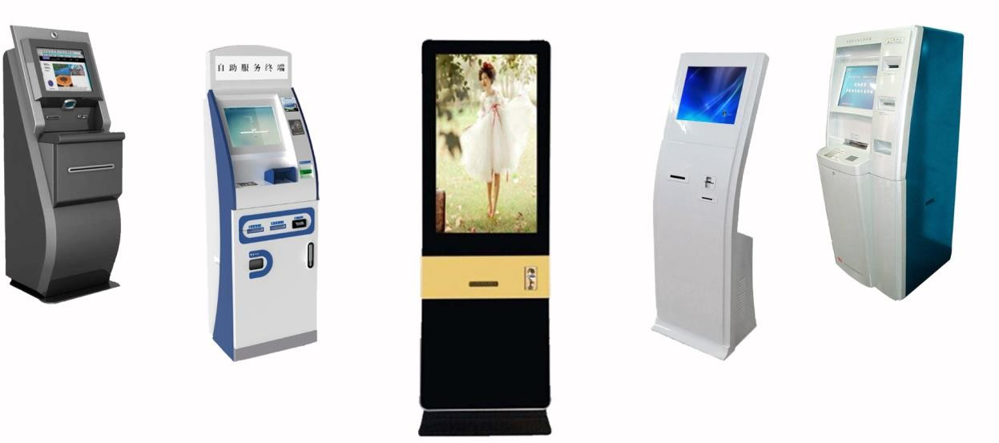

Printer installation

Refer to the M80 3D drawing

Control board interface definition diagram：

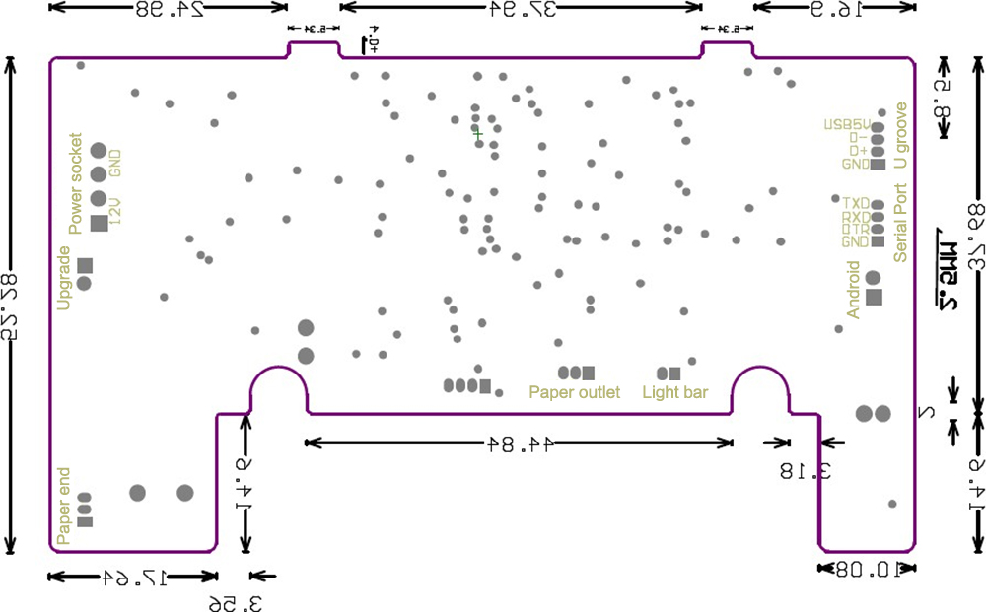

Control board interface definition：

Serial Port（CN11）RS232

|  |  |
| --- | --- |
| Printer terminal | Computer terminal |
| 1 GND | 5 GND |
| 2 DTR | 6，8 DTR |
| 3 RXD | 3 RXD |
| 4 TXD | 2 TXD |

Power socket（CN3）definition：

|  |  |
| --- | --- |
| 1 | +12V |
| 2 | +12V |
| 3 | GND |
| 4 | GND |

Printer installation and operation：

Installation method of hole fixation

1. Press the spring into the fixing piece, then place the fixing piece and the pressing spring according to the direction shown in the figure.
2. After the screw hole is aligned with the shell screw hole, put the printer into the hole area, hit the round head tooth screw,  and rotate it clockwise to fix it.
3. After both sides of the installation, you must determine the printer's stability before operation.
4. When installing the printer, keep turning the screws clockwise until the printer is firmly installed.
5. The printer can be separated from the fixed parts by constantly rotating the head screw counterclockwise.

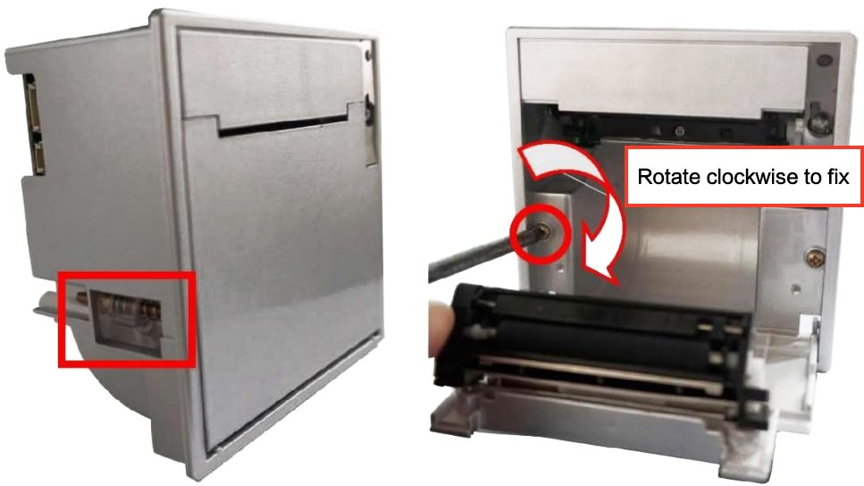

This printer can be installed horizontally or vertically（Do not install the printer upside down）

Open the paper bin cover and change the paper

1. Turn off the wrench or insert the key into the lock by aligning it with the lock hole(Pay attention to the lock).
2. Turn the key counterclockwise until it sends back the open cover.
3. After opening the cover successfully, turn the key clockwise to reset and take out the key.
4. Remove the remaining paper tube, roll up the newly loaded paper, put it into the paper bin with the printing side (thermal coating) upward, and pull out a small section of paper, as shown in the figure
5. Make sure that the paper is not skewed and close the bin cover

Printer indicator light

Panel indicator light, used to indicate the various state of the printer after power, the meaning is as follows：

1. The green light is on, which means the power is on and the printer is normal.
2. The red light flashes, indicating that the printer is wrong, the cover is open or the cutter is not reset.
3. The red light is always on, indicating that there is a shortage of paper.

Self test page printing

1. When the printer is in standby mode, press the power indicator for about 1 second.
2. Once the light flashes, release the power indicator, print the self test page；

Enter and exit hexadecimal mode：

1. In standby mode, press the power indicator for about 2 seconds.
2. When the light flashes twice, release the power indicator. The word "dump mode" is printed to indicate that the printer is in hexadecimal mode.
3. Press the power indicator again to exit hexadecimal mode.

Printer instruction set

**Command List：**

|  |  |  |  |  |  |
| --- | --- | --- | --- | --- | --- |
| Command | Name | Command classification | | Standard mode | Page mode |
| Execute Command | Setting command |
| **HT** | Horizontal positioning | ○ |  | ○ | ○ |
| **LF** | Print and line feed | ○ |  | ○ | ○ |
| **FF** | Print and return to standard mode (In page mode) | ○ |  | Ignore | ○ |
| Print and feed the black label to the printing start position | ○ |  | ○ | Forbid |
| **CR** | Print and carriage return | ○ |  | ○ | ○ |
| **CAN** | Cancel printing data in page mode | ○ |  | Ignore | ○ |
| **DLE EOT** | Real-time state transmission | ○ |  | ○ | ○ |
| **ESC FF** | Print data in page mode | ○ |  | Ignore | ○ |
| **ESC SP** | Set the right character spacing |  | ○ | ○ | ○ |
| **ESC !** | Select Print mode |  | ○ | ○ | ○ |
| **ESC $** | Set the absolute print position | ○ |  | ○ | ○ |
| **ESC %** | Select/cancel user-defined character sets |  | ○ | ○ | ○ |
| **ESC &** | Define user-defined characters |  | ○ | ○ | ○ |
| **ESC \*** | Select the bitmap mode | ○ |  | ○ | ○ |
| **ESC -** | Set/Unset underline |  | ○ | ○ | ○ |
| **ESC 2** | Select the default line spacing |  | ○ | ○ | ○ |
| **ESC 3** | Set line spacing |  | ○ | ○ | ○ |
| **ESC ?** | Cancel user-defined characters |  | ○ | ○ | ○ |
| **ESC @** | Initialize printer | ○ | ○ | ○ | ○ |
| **ESC D** | Set horizontal anchor point |  | ○ | ○ | ○ |
| **ESC E** | Set/Unset bold printing |  | ○ | ○ | ○ |
| **ESC G** | Set/Unset overlay printing |  | ○ | ○ | ○ |
| **ESC J** | Print and feed paper | ○ |  | ○ | ○ |
| **ESC L** | Select page mode | ○ |  | （○） | Ignore |
| **ESC M** | Select font |  |  | ○ | ○ |
| **ESC R** | Select international Character Set |  | ○ | ○ | ○ |
| **ESC S** | Select standard mode | ○ |  | Ignore | ○ |
| **ESC T** | Select print direction in page mode |  | ○ | ▲ | ○ |
| **ESC V** | Set/Unset 90 degree clockwise rotation |  | ○ | ○ | ▲ |
| **ESC W** | Set the print area in page mode |  | ○ | ▲ | ○ |
| **ESC \** | Sets the relative print position | ○ |  | ○ | ○ |
| **ESC a** | Select alignment |  | ○ | （○） | ▲ |
| **ESC c 3** | Select printer paper sensor to output paper shortage signal |  | ○ | ○ | ○ |
| **ESC c 4** | Select printer paper sensor to stop printing |  | ○ | ○ | ○ |
| **ESC c 5** | Activate/disable panel button |  | ○ | ○ | ○ |
| **ESC d** | Print and feed paper N lines | ○ |  | ○ | ○ |
| **ESC t** | Select the character code table |  | ○ | ○ | ○ |
| **ESC {** | Set/Unset reverse print mode |  | ○ | （○） | ▲ |
| **FS p** | Print NV bitmap | ○ |  | ○ | ○ |
| **FS q** | Define NV bitmap |  | ○ | （○） | ○ |
| **GS FF** | Feed the black label printing paper to the printing start position | ○ |  | ○ | ○ |
| **GS !** | Set character size |  | ○ | ○ | ○ |
| **GS $** | Set the absolute vertical print position in page mode | ○ |  | Ignore | ○ |
| **GS ** | Define download bitmap |  | ○ | ○ | ○ |
| **GS /** | Print download bitmap | ○ |  | ● | ○ |
| **GS B** | Set/Unset reverse print mode |  | ○ | ○ | ○ |
| **GS H** | Select the print position of the HRI character |  | ○ | ○ | ○ |
| **GS I** | Transfer printer ID | ○ |  | ○ | ○ |
| **GS L** | Set the left margin |  | ○ | （○） | ▲ |
| **GS V** | Select the paper cutting mode and cut the paper | ○ |  | （○） | ○ |
| **GS W** | Set the print area width |  | ○ | （○） | ▲ |
| **GS \** | Set the relative vertical print position in page mode | ○ |  | Ignore | ○ |
| **GS a** | Allow / prohibit automatic status reply(ASB) | ○ | ○ | ○ | ○ |
| **GS f** | Select the HRI character font |  | ○ | ○ | ○ |
| **GS h** | Set bar code height |  | ○ | ○ | ○ |
| **GS k** | Printed bar code | ○ |  | ● | ○ |
| **GS r** | Transfer state | ○ |  | ○ | ○ |
| **GS v 0** | Print raster bitmap | ○ |  | ● | ○ |
| GS w | Set bar code width |  | ○ | ○ |  |

There are new label paper and thermal paper switching instructions, please refer to the last page for details.

**Chinese character command list：**

|  |  |  |  |  |  |
| --- | --- | --- | --- | --- | --- |
| Command | Name | Command classification | | Standard mode | Page mode |
| Executive Command | Set command |
| **FS !** | Set Chinese character printing mode combination |  | ○ | ○ | ○ |
| **FS &** | Set Chinese character mode |  | ○ | ○ | ○ |
| **FS -** | Set/Unset Chinese character underline |  | ○ | ○ | ○ |
| **FS .** | Unset Chinese character mode |  | ○ | ○ | ○ |
| **FS 2** | Define user-defined Chinese characters |  | ○ | ○ | ○ |
| **FS S** | Set full width Chinese character spacing |  | ○ | ○ | ○ |
| **FS W** | Set/Unset quadruple angle Chinese printing |  | ○ | ○ | ○ |
| **GS0103** | Set the QR CODE size |  | ○ | ○ |  |
| **GS0104** | Set the error correction level of QRCODE |  | ○ | ○ |  |
| **GS0101** | QRCODE data |  | ○ | ○ |  |
| **Gs0102** | Print QRCODE | ○ |  | ○ |  |
|  | Light on |  |  |  |  |
|  | Light off |  |  |  |  |

Executive Command: The printer executes this command, and the change of command does not affect subsequent data.

Setting Command: The printer is set with the appropriate flag bits, which affect the subsequent data.

Standard mode: allow.

( ): A command is valid only if it is at the beginning of a line.

* : Only valid if there is no data in the print buffer.

Page Mode: allow.

▲: Only numerical setting is allowed.

Prohibit： Parameters are processed as printable data.

Ignore： Ignore all command code, including parameters, and perform nothing

**Control print command details：**

HT

[Name] Horizontal positioning

[Format]  ASCII code HT

Hexadecimal code 09

Decimal code 9

[Description]  Move the print position to the next horizontal anchor point.

[Detailed description] • If the location of the next horizontal anchor point is not set, the command is ignored.

* + - * If the next horizontal anchor point is outside the print area, move the print position to “print area width +1”.
      * Use the ESC D command to set the location of the horizontal anchor point.
      * When the printing position is located at "print area width + 1", the printer receives this command, and the printer executes the print buffer to print the current line, and horizontally locates the next line at the beginning of processing.

[Reference] **ESC D**

LF

[Name] Print and line feed

[Format] ASCII code LF

Hexadecimal code 0A

Decimal code 10

[Description] Print out the data in the print buffer and push the paper forward one line at the current line spacing.

[Note] This command sets the print position to the beginning of the line.

[Reference] **ESC 2， ESC 3**

FF

[Name] ①Print and return to standard mode（In page mode）

②Print and move the black label to the start of the print

① When selecting page mode：

[Description] Prints out all the data in the print buffer and returns to standard mode

[Note] • This command only works in page mode.

* After printing, delete the data in the print buffer.
* Reset the print area settings set by ESC W to the default settings.
* This command sets the print position as the starting point of the line.

[Reference] **ESC FF , ESC L , ESC S**

② When BM sensor is effective：

[Description] Prints the data in the print buffer and feeds the black label paper to the start of the print.

[Note] •  This command is only allowed if the BM sensor is set to be valid using DIP SW1-1.

* This command sets the print position as the starting point of the line.
* If the command is executed at the printing start position of the black marked printing paper, the printer will feed the black marked printing paper to the next printing start position.

[Reference] **GS ( F, GS FF**

CR

[Name]  Print and carriage return

[Format] ASCII code CR

Hexadecimal code 0D

Decimal code 13

[Description] This command will be ignored.

[Detailed description] This command will be ignored.

## CAN

[Name] Cancel printing data in page mode

[Format] ASCII code CAN

Hexadecimal code 18

Decimal code 24

[Description] In page mode, delete all print data in the current print area.

[Detailed description] This command is allowed only in page mode.

Data in the specified print area is deleted.

[Reference] **ESC L , ESC W**

## DLE EOT n

[Name] Real-time state transmission

[Format] ASCII code DLE EOT n

Hexadecimal code 10 04 n

Decimal code 16 4 n

[Scope] 1≤n ≤4

[Description] Transmit printer status in real time. The parameter n is used to specify the state of the printer to be transferred. Definition:

n = 1: Transmit printer status

n = 2: Transmit off line state

n = 3: Transmit error status

n = 4: Transmit roll sensor status

[Detailed description] • The printer transmits the current state, one byte of data per state.

* When sending status, the printer does not confirm that the host can receive data.
* The printer executes when it receives the command.
* In serial interface mode, this command is executed even when the printer is offline, the receive buffer is full, or an error state occurs.

[Note] • Whenever the <10>H<04>H<n>(1  n  4) data sequence is received, the status will be transmitted.

For example, in the following command:

**ESC * m nL nH d1 ... dk** , d1=<10>H, d2=<04>H, d3=<01>H

* You should not use this command in a command that contains two or more bytes.
* For example：

If you want to send **ESC 3N** to the printer, DTR will change to MARK before n is sent, so **DLE EOT 3** interrupt occurs before n is received. **DLE EOT 3** code <10>H will be treated as **ESC 3** code <10>H

n = 1 Printer Status

|  |  |  |  |  |
| --- | --- | --- | --- | --- |
| Bit | Turn off/on | Hexadecimal code | Decimal code | Function |
| 0 | Turn off | 00 | 0 | Not used. Fixed is off. |
| 1  2 | Turn on | 02 | 2 | Not used. Fixed is on. |
| Turn on | 04 | 4 | Not used. Fixed is on. |
| 3 | Turn off | 00 | 0 | On-line. |
| Turn on | 08 | 8 | Off-line. |
| 4 | Turn on | 10 | 16 | Not used. Fixed is on. |
| 5 | Turn off | 00 | 0 | Do not wait for on-line error recovery. |
| Turn on | 20 | 32 | Wait for on-line error recovery. |
| 6 | Turn off | 00 | 0 |  |
| Turn on | 40 | 64 |  |
| 7 | Turn off | 00 | 0 | Not used. Fixed is off. |

n = 2 ：Off-line state

|  |  |  |  |  |
| --- | --- | --- | --- | --- |
| Bit | Turn off/Turn on | Hexadecimal code | Decimal code | Function |
| 0 | Turn off | 00 | 0 | Used. Fixed is off. |
| 1 | Turn on | 02 | 2 | Not used. Fixed is on. |
| 2 | Turn off | 00 | 0 | The machine head lever is off. |
| On | 04 | 4 | The machine head lever is on. |
| 3 | Turn off | 00 | 0 | Do not feed paper through the feed button. |
| Turn on | 08 | 8 | Feed paper through the feed button. |
| 4 | Turn on | 10 | 16 | Not used. Fixed is on. |
| 5 | Turn off | 00 | 0 | The print paper is not used up. |
| Turn on | 20 | 32 | Stop printing when run out of paper. |
| 6 | Turn off | 00 | 0 | No error. |
| Turn on | 40 | 64 | Error occurred. |
| 7 | Turn off | 00 | 0 | Not used. Fixed is off. |

Bit 5：Turns on when the paper shortage sensor detects that the paper has run out and stops printing.

n = 3: Error condition

|  |  |  |  |  |
| --- | --- | --- | --- | --- |
| Bit | Turn off/Turn on | Hexadecimal code | Decimal code | Function |
| 0 | Turn off | 00 | 0 | Not used. Fixed is off. |
| 1 | Turn on | 02 | 2 | Not used. Fixed is on. |
| 2 | Turn off | 00 | 0 | No mechanical errors. |
| Turn on | 04 | 4 | Mechanical error occurred. |
| 3 | Turn off | 00 | 0 | There are no automatic paper cutting errors. |
| Turn on | 08 | 8 | An automatic paper cutting error has occurred. |
| 4 | Turn on | 10 | 16 | Not used. Fixed is on. |
| 5 | Turn off | 00 | 0 | There are no unrecoverable errors. |
| Turn on | 20 | 32 | An unrecoverable error has occurred. |
| 6 | Turn off | 00 | 0 | There are no auto-recoverable errors. |
| Turn on | 40 | 64 | An auto-recoverable error has occurred. |
| 7 | Turn off | 00 | 0 | Not used. Fixed is off. |

Bit 2： The printer classified the lifting of the machine head level and the absence of BM during printing as a mechanical error.

Bit 6：If the temperature of the print head is too high during printing, bit 6 will be set to on until the temperature of the print head is effectively lowered or when the machine head lever is turned on during printing.

n = 4: Continuous using paper sensor status

|  |  |  |  |  |
| --- | --- | --- | --- | --- |
| Bit | Turn off/Turn on | Hexadecimal code | Decimal code | Function |
| 0 | Turn off | 00 | 0 | Not used. Fixed is off. |
| 1 | Turn on | 02 | 2 | Not used. Fixed is on. |
| 2，  3 | Turn off | 00 | 0 | Paper end detector，the paper is enough。 |
| Turn on | 0C | 12 | The paper end detector detects that the paper is near the end. |
| 4 | Turn on | 10 | 16 | Not used. Fixed is on. |
| 5，  6 | Turn off | 00 | 0 | Paper end detector：have paper |
| Turn on | 60 | 96 | The paper end detector detects that the paper is end. |
| 7 | Turn off | 00 | 0 | Not used. Fixed is off. |

[Reference] **DLE ENQ**， **GS a**， **GS r**，Appendix C

## ESC FF

[Name] Print data in page mode

[Format] ASCII code ESC FF

Hexadecimal code 1B 0C

Decimal code 27 12

[Description] In page mode, centralize all data in the print buffer in the print area

[Detailed description] • This command only works in page mode.

* After printing, the printer does not clear the settings of data ESC T and ESC w in the buffer and the position of character data in the buffer.

[Reference] **FF** , **ESC L** , **ESC S**

## ESC SP n

[Name] Set the right character spacing

[Format] ASCII code ESC SP n

Hexadecimal code 1B 20 n

Decimal code 27 32 n

[Scope] 0 ≤n ≤255

[Description] Set the right character spacing to [n X 0.125 mm].

[Detailed description] • In double width mode, the right character spacing is twice as large as in normal mode. When a character is amplified n times, the right margin of the character is n times the normal mode.

* + This command does not affect the setting of Chinese characters.
  + This command sets the right character spacing in standard mode and page mode, respectively.

[Default value] n = 0

## ESC ! n

[Command] Select print mode

[Format] ASCII code ESC ! n

Hexadecimal code 1B 21 n

Decimal code 27 33 n

[Scope] 0 ≤ n ≤ 255

[Description] Select the print mode by specifying the value of the parameter n.The parameter n is defined as follows:

|  |  |  |  |  |
| --- | --- | --- | --- | --- |
| Bit | Turn off/on | Hexadecimal code | Decimal code | Function |
| 0 | Off | 00 | 0 | Character font A (12  24)。 |
| On | 01 | 1 | Character font B (9  17)。 |
| 1 | - | - | - | Undefined |
| 2 | - | - | - | Undefined |
| 3 | Off |  | 0 | Unset the aggravation mode. |
| On |  | 8 | Set the aggravation mode. |
| 4 | Off |  | 0 | Unset the double height mode. |
| On |  | 16 | Set the double height mode. |
| 5 | Off |  | 0 | Unset double width mode. |
| On |  | 32 | Set double width mode. |
| 6 | - | - | -- | Undefined. |
| 7 | Off |  | 0 | Unset underline mode。 |
| On |  | 128 | Set underline mode. |

[Detailed description] • When double-height and double-width modes are selected at the same time, four-size characters are printed.

* + - The printer can underline all characters, but cannot underline white space generated by the HT command or characters rotated 90 degrees clockwise.
    - The size of the underline is set by ESC - and is independent of character size.
    - When there are some characters of multiple height or higher in a line, all characters in the line are aligned along the baseline.
    - **ESC M** can also set the font type of characters. The Settings of the last command received are valid.
    - **ESC E** can also be set or unset aggravation mode. The Settings of the last command received are valid.
    - **ESC -** ESC can also set or unset underline mode, the last command received is set valid.
    - **GS !** can also set character size. The Settings of the last command received are valid.
    - The weight mode works for both English and Chinese characters.

[Default value] n = 0

[Reference] **ESC -**, **ESC E**, **GS !**

## ESC $ nL nH

[Name] Set the absolute print position

[Format] ASCII code ESC $ nL nH

Hexadecimal code 1B 24 nL nH

Decimal code 27 36 nL nH

[Scope] 0 ≤ nL ≤ 255

0 ≤ nH≤255

[Description] Sets the distance from the beginning of a line to the position of the character to be printed.

* + The distance from the beginning of a line to the print position is [(nL + nH X 256) X 0.125 mm]。

[Detailed description] • Settings outside the specified print area are ignored.

* + In standard mode, use horizontal motion units (x).
  + In page mode, units of horizontal or vertical motion vary depending on the starting position of the printable area, as shown below:

①When ESC T is used to set the starting position to the upper left or lower right of the printable area, the horizontal moving unit (x) is used.

②When ESC T is used to set the starting position to the upper right or lower left of the printable area, the vertical moving unit (y) is used.

[Reference] **ESC \**, **GS $**, **GS \**

ESC n

[Name] Select/cancel user-defined character sets

[Format] ASCII code ESC % n

Hexadecimal code 1B 25 n

Decimal code 27 37 n

[Scope] 0≤n≤ 255

[Description] Select or cancel the user-defined character set.

* + - When the least significant bit (LSB) of n is 0, the user-defined character set is canceled.
    - When the least significant bit (LSB) of n is 1, the user-defined character set is selected.

[Detailed description] • Internal character sets are automatically selected when user-defined character sets are canceled.

* + - n is only useful in the least significant bits.

[Default value] n = 0

[Reference] **ESC &** , **ESC ?**

ESC & y c1 c2 [x1 d1...d(y × x1)]...[xk d1...d(y ×xk)]

[Name] Define user-defined characters

[Format] ASCII code ESC & y c1 c2 [x1 d1...d(y×x1)]...[xk d1...d(y×xk)]

Hexadecimal code 1B 26 y c1 c2 [x1 d1...d(y×x1)]...[xk d1...d(y×xk)]

Decimal code 27 38 y c1 c2 [x1 d1...d(y×x1)]...[xk d1...d(y×xk)]

[Scope] y = 3

32 ≤c1 ≤c2 ≤126

0 ≤ x ≤ 12 When setting font A(12× 24), it only works for font 12X24.

0 ≤ d1...d(y×xk) ≤ 255

[Description] Define user-defined characters.

* + - y specifies the number of bytes in the vertical direction.
    - c1 specifies the start character encoding and C2 specifies the ending character encoding.
    - x specifies the number of points in the horizontal direction.

[Detailed description] • Support for this directive may vary from program version to program version, depending on the version actually used.

* + - The range of character encodings can be defined：ASCII code (95 characters) from <20>H to <7E>H.
    - A continuous character encoding that can define more than one character. When only one character is required, let C1 = C2.
    - d is the dot data of the character. Dot mode is the horizontal direction starting from the left. The remaining dots on the right are blank.
    - The data that defines user-defined characters is (y×x) bytes.
    - Set the corresponding bit of the print point to 1 or the corresponding bit of the non-print point to 0.
    - User-defined characters and download bitmaps cannot be defined at the same time. When this command is executed, the download bitmap is cleared.
    - User-defined characters are cleared in the following cases:

① Perform **ESC @**.

② Perform **GS \***.

③ Perform **ESC ?**.

④ Printer reset or power off.

[Default value] Internal character set

[Reference] **ESC %** , **ESC ?** [Examples]

* When font A (12 × 24) is set.

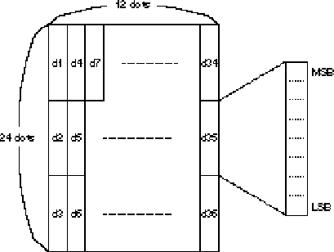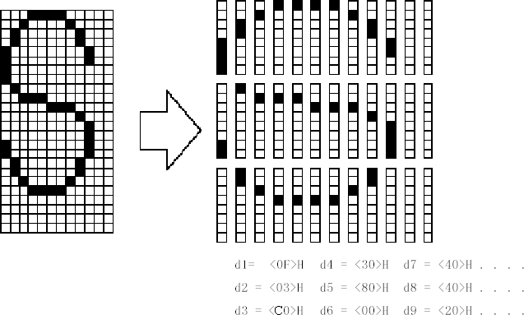

ESC * m nL nH d1... dk

[Name] Select the bitmap mode

[Format] ASCII code ESC * m nL nH d1...dk

Hexadecimal code 1B 2A m nL nH d1...dk

Decimal code 27 42 m nL nH d1...dk

[Scope] m = 0, 1, 32, 33

0 ≤nL ≤255

0 ≤nH≤ 3

0 ≤ d≤ 255

[Description] Select the bitmap mode with m, and the number of bitmap points is specified by nL and nH, as shown below:

|  |  |  |  |  |  |
| --- | --- | --- | --- | --- | --- |
| m | Mode | Vertical direction | | Horizontal direction | |
| Dots | Dot density | Dot density | Number of data (K) |
| 0 | 8-dot single density | 8 | 67.7 dpi | 101.6 dpi | nL + nH X 256 |
| 1 | 8-dot dual density | 8 | 67.7 dpi | 203.2 dpi | nL + nH X 256 |
| 32 | 24-dot single density | 24 | 203.2 dpi | 101.6 dpi | (nL + nH X256) X3 |
| 33 | 24-dot dual density | 24 | 203.2 dpi | 203.2 dpi | (nL + nH X256) X3 |

Dpi: Print dot per 25.4 mm{1 inch}

[Note] • If the value of m exceeds the specified range, then nL and subsequent data are treated as normal data.

* + - nL and nH represent the number of points in the bitmap horizontally. The number of points is calculated by nL + nH 256.
    - If the bitmap data input exceeds the number of dots on a line that can be printed, the excess data is ignored.
    - d represents bitmap data. Set the corresponding bit to 1 to print a dot, or set it to 0 to not print a dot.
    - If the width of the print range set with GS L and GS W is smaller than the width required for data sent with the ESC command, perform the following actions on the line in question（However, printing must not exceed the maximum printable range）：

① The width of the print area is extended to the right to accommodate the amount of data.

② If step ① does not provide sufficient width for the data, the left edge is reduced to accommodate the data. For each bit of data in single density mode (m = 0, 32), the printer prints two dots：For each bit of data in double density mode(m = 1, 33), the printer prints one dot. These must be taken into account when calculating the amount of data that can be printed on a line.

* + - After printing a bitmap, the printer returns to normal data processing mode.
    - This command is not affected by print mode unless you are reversing print mode (bold, overlapping, underscore, character size, or reverse printing).
    - The following figure describes the relationship between the image data and the dot being printed.

When the 8-inode bitmap is selected：

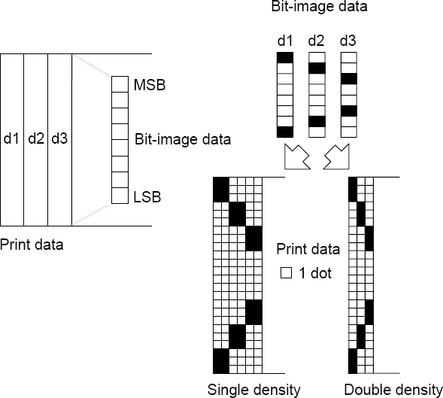

* When the 24-inode bitmap is selected:

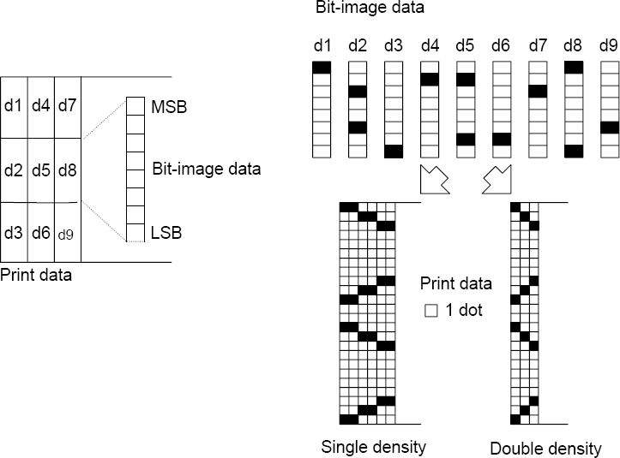

ESC – n

[Name] Set/Unset underline

[Format] ASCII code ESC - n

Hexadecimal code 1B 2D n

Decimal code 27 45 n

[Scope] 0 ≤n ≤2, 48≤ n≤ 50

[Description] Set/unset underline mode based on the following n values:

|  |  |
| --- | --- |
| n | Function |
| 0, 48 | Unset underline mode |
| 1, 49 | Set underline mode (1 dot thick) |
| 2, 50 | Set underline mode (2 dots thick) |

[Note] The printer can print underlines (include the space to the right of the character) for all characters except for whitespace set by HT.

* + - The printer cannot underline characters that are rotated 90 clockwise or reversed.
    - When the underline mode is cancelled by setting the value of n to 0 or 48, the subsequent data will not be underlined, and the thickness of the underline set before removing the underline mode will not be changed. The default underline thickness is 1 dot.
    - Changing the character size does not affect the size of the current underline.
    - ESC ! can also be used to set or unset underline mode. However, note that the last command received is valid.

[Default value] n = 0

[Reference] **ESC !**

## ESC 2

[Name] Select the default line spacing

[Format] ASCII code ESC 2

Hexadecimal code 1B 32

Decimal code 27 50

[Description] Select line spacing of 3.75 mm (30 X 0.125 mm).

[Note] Line spacing can be set independently in standard mode and page mode.

[Reference] **ESC 3**

ESC 3 n

[Name] Set line spacing

[Format] ASCII code ESC 3 n

Hexadecimal code 1B 33 n

Decimal code 27 51 n

[Scope] 0 ≤ n≤255

[Description] Set the line spacing to [n X 0.125 mm].

[Note] Line spacing can be set independently in standard mode and page mode.

In standard mode, the unit of vertical motion (y) is used.

In page mode, according to the starting position of the printable area. The functions of this command are as follows：

① When **ESC T** is used to set the starting position to the upper left or lower right of the printable area, the vertical motion unit (y) is used.

② When **ESC T** is used to set the starting position to the upper right or lower left of the printable area, the horizontal motion unit (x) is used.

[Default value] n = 30

[Reference] **ESC 2**

ESC ? n

[Name]  Cancel user defined characters

[Format] ASCII code ESC ? n

Hexadecimal code 1B 3F n

Decimal code 27 63 n

[Scope] 32 ≤ n ≤ 126

[Description] Cancel user defined characters

[Note] This command terminates the use of the style defined for the character encoding specified by n. After the user-defined characters are canceled, they are printed in the corresponding mode of internal characters.

In the font selected with **ESC !**, the command removes the style defined for the specified encoding.

If a user-defined character is not defined, the printer ignores the command.

[Reference] **ESC &** , **ESC %**

## ESC @

[Name] Initialize printer

[Format] ASCII code ESC @

Hexadecimal code 1B 40

Decimal code 27 64

[Description] Clears the data in the print buffer, and reset the printer mode to the valid mode of the printer when the power is on.

[Note] Dip toggle switch settings are no longer checked

The data in the receive buffer is not cleared.

## ESC D n1 . . . nk NUL

[Name] Set the horizontal anchor point

[Format] ASCII code ESC D n1 nk NUL

Hexadecimal code 1B 44 n1 nk 00

Decimal code 27 68 n1 nk 0

[Scope] 1 ≤n ≤255

0 ≤ k ≤ 32

[Description] Set the horizontal positioning position.

n specifies the column number starting from a row and is used to set the horizontal positioning position.

k is the total number of horizontal positioning positions to be set.

[Note] The horizontal positioning position is stored as a value of [Character width X n], which is measured from the row. The character width includes the right space of the character, and the double width character is set at twice the width of the normal character.

This command removes the previously set horizontal positioning position.

When n = 8 is set, the print position is moved to column 9 by sending the HT。

You can set up to 32 positioning positions(k = 32)。Data exceeding 32 positioning positions are processed as normal data.

Transmit [n] k in ascending order and place a NUL code 0 at the end.

When [n] k is less than or equal to the previous value [n] k 1, the positioning setting ends and the subsequent data is processed as normal data.

**ESC D NUL** cancels all horizontal positioning positions.

The previously specified horizontal positioning position remains unchanged even if the character width changes.

For standard and page modes, character widths are remembered.

[Default value] The default location is the 8-character interval(column 9，17，25 ) of font A(12  24).

[Reference] **HT**

## ESC E n

[Name] Set/unset aggravation print

[Format] ASCII code ESC E n

Hexadecimal code 1B 45 n

Decimal code 27 69 n

[Scope] 0≤n≤ 255

[Description] Set or unset aggravation print mode.

When the least significant bit (LSB) of n is 0, the aggravation printing mode is unset.

[Note] Only the least significant bit of n is allowed.

This command sets and unsets bold print mode in the same way as ESC !.Be careful when using this command in conjunction with ESC !.

[Default value] n = 0

[Reference] **ESC !**

## ESC G n

[Name] Set/unset overlapping print

[Format] ASCII code ESC G n

Hexadecimal code 1B 47 n

Decimal code 27 71 n

[Scope] 0 ≤ n ≤ 255

[Description] Sets or unset overlapping print mode.

When the least significant bit of n (LSB) is 0, the overlapping printing mode is unset.

When the least significant bit of n (LSB) is 1, the overlapping printing mode is set.

[Note] Only the least significant bit of n is allowed.

The printer output is the same in overlap mode and bold mode.

[Default value] n = 0

[Reference] **ESC E**

ESC J n

[Name] Print and feed paper.

[Format] ASCII code ESC J n

Hexadecimal code 1B 4A n

Decimal code 27 74 n

[Scope] 0 ≤n ≤ 255

[Description] Print out the data in the print buffer and feed paper [n X 0.125 mm].

[Note] After printing, this command sets the printer's starting position as the line starting point.

The paper feed amount set by this command does not affect the values set by the ESC 2 or ESC 3 commands.

In standard mode, the printer uses the vertical motion unit (y).

In page mode, depending on the starting location of the printable area, the functions of this command are as follows:

① When **ESC T** is used to set the starting position to the upper left or lower right of the printable area, the vertical motion unit (y) is used.

② When **ESC T** is used to set the starting position to the upper right or lower left of the printable area, the horizontal motion unit (x) is used.

This command is valid in standard mode even if the value set exceeds the maximum within the range of the BM sensor. (BM =Black mark)

## ESC L

[Name] Select page mode

[Format] ASCII code ESC L

Hexadecimal code 1B 4C

Decimal code 27 76

[Description] Switch from standard mode to page mode.

[Note] In standard mode, this command is only valid at the beginning of a line.

This command is not valid in page mode.

The printer returns to standard mode after the FF end print or **ESC S** command is executed.

This command sets the position of the data buffer to the position specified by the **ESC T** command within the print area.

This command switches the settings for the following commands (In these commands, the values for standard mode and page mode can be set separately)to the corresponding settings in page mode.

① Set the right character spacing：**ESC SP**

② Select the default line spacing：**ESC 2 , ESC 3**

* + In page mode, only the following commands can be set;But these commands are not executed.

① Set / cancel 90 degree clockwise rotation：**ESC V**

② Select alignment：**ESC a**

③ Set/cancel upside-down print mode：**ESC {**

④ Set the left margin：**GS L**

⑤ Set the print area width：**GS W**

Turn on the printer power, print reset or use the ESC @ command, and the printer returns to the standard mode.

[Reference] **FF** , **CAN , ESC FF** , **ESC S** , **ESC T** , **ESC W** , **GS $** , **GS \**

ESC M n

[Name] Select fonts

[Format]

ASCII code ESC M n

Hexadecimal code 1B 4D n

Decimal code 27 77 n

[Scope] n = 0, 1, 48, 49

[Description] Select the character font

|  |  |
| --- | --- |
| n | Function |
| 0, 48 | Select font A (12  24) |
| 1, 49 | Select font B (9  17) |

[Detailed description] • **ESC !** can also select the font type, but the settings made by the last command received are valid.

[Reference] **ESC !**

ESC R n

[Name] Select international Character Set

[Format] ASCII code ESC R n

Hexadecimal code 1B 52 n

Decimal code 27 82 n

[Scope] 0≤ n ≤ 13

[Description] Select the value of n from the following table to set the international character set.

|  |  |
| --- | --- |
| n | character set |
| 0 | America |
| 1 | France |
| 2 | Germany |
| 3 | Britain |
| 4 | Denmark I |
| 5 | Sweden |
| 6 | Italy |
| 7 | Spain I |
| 8 | Japan |
| 9 | Norway |
| 10 | Denmark II |
| 11 | Spain II |
| 12 | Latin America |
| 13 | Korea |

[Default value] n = 0

[Reference] International Character Set

## ESC S

[Name] Select standard mode

[Format] ASCII code ESC S

Hexadecimal code 1B 53

Decimal code 27 83

[Description] Switch from page mode to standard mode.

[Note] This command only works in page mode.

In page mode, the data in the buffer is cleared.

This command sets the print position as the starting point of the line.

The printing area setting set by **ESC W** is initialized.

This command switches the settings made to the following commands to the corresponding settings in standard mode(In these commands, the values for standard mode and page mode can be set separately):

① Set the right character spacing：**ESC SP**

② Select the default line spacing： **ESC 2** , **ESC 3**

[Reference] **FF** , **ESC FF** , **ESC L**

ESC T n

[Name] Select the print direction in page mode

[Format] ASCII code ESC T n

Hexadecimal code 1B 54 n

Decimal code 27 84 n

[Scope] 0 ≤n≤ 3

48≤ n ≤ 51

[Description] Select the print direction and starting position in page mode.

The parameter n is used to specify the direction and starting position of printing, as shown below:

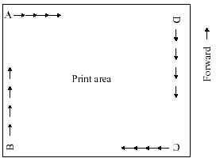

|  |  |  |
| --- | --- | --- |
| n | Print direction | Starting position |
| *0，48* | From left to right | Upper left（Figure A） |
| *1，49* | From bottom to top | Lower left（Figure B） |
| 2，50 | From right to left | Lower right（Figure C） |
| 3，51 | From top to bottom | Upper right（Figure D） |

[Note]

• When this command is entered in standard mode, the printer performs only internal flag operations. This command does not affect printing in standard mode.

This command sets the data cache location within the printing area set by ESC W.

[Default value] n = 0

[Reference] **ESC $** , **ESC L** , **ESC W** , **ESC \** , **GS $** , **GS \**

ESC V n

[Name] Set/Unset rotation 90 degrees clockwise

[Format] ASCII code ESC V n

Hexadecimal code 1B 56 n

Decimal code 27 86 n

[Scope] 0 ≤ n ≤ 1, 48≤ n ≤49

[Description] Set/Unset rotation 90 degrees clockwise

The use of n is shown as follows:

|  |  |
| --- | --- |
| N | Function |
| 0, 48 | Unset rotation 90 degrees clockwise mode |
| 1, 49 | Set rotation 90 degrees clockwise mode |

[Note] This command affects printing in standard mode. And the Settings are always valid.

When underline mode is set, the printer does not underline characters that rotate clockwise 90 degrees.

In the clockwise 90 degree rotation mode, the direction of enlarging characters by double height and width commands is opposite to that of general mode.

If this command is entered in page mode, the printer operates only on internal flag bits.

[Default value] n = 0

[Reference] **ESC !** , **ESC -**

ESC W xL xH yL yH dxL dxH dyL dyH

[Name] Set the print area in page mode

[Format] ASCII code ESC W xL xH yL yH dxL dxH dyL dyH

Hexadecimal code 1B 57 xL xH yL yH dxL dxH dyL dyH

Decimal code 27 87 xL xH yL yH dxL dxH dyL dyH

[Scope] 0 ≤ xL,xH,yL,yH,dxL,dxH,dyL,dyH≤255 (Except dxL = dxH =0 or dyL = dyH =0)

[Description] x0, y0, dx, dy define horizontal starting position, vertical starting position, print area width and print area height respectively.

Each set value of the printing area is calculated as follows:

x0 = [(xL + xH x 256) x 0.125 mm]

y0 = [(yL + yH x 256) x 0.125 mm]

dx = [(dxL + dxH x256) x 0.125 mm]

dy = [(dyL + dyH x256)x 0.125 mm]

[Note] If the command is entered in standard mode, the printer performs only internal flag operations. This command does not affect printing in standard mode.

If the setting of the horizontal start position and vertical start position exceeds the printable range, the printer stops the command processing and processes the subsequent data as normal data.

If the width and height of the printing area are set to 0, the printer stops command processing and processes subsequent data as normal data.

This command sets the position of the data buffer to the position specified by ESC T within the printing area.

If the (horizontal starting position + print area width) exceeds the printable area, the print area width is automatically set to the (horizontal printable area - horizontal starting position).

If the (vertical starting position + print area height) exceeds the printable area, the print area height is automatically set to the (vertical printable area - vertical starting position).

Use 0.125mm spacing to set the horizontal start position and print area width, and use 0.125mm spacing to set the vertical start position and print area height.

x0, y0, dx and dy respectively define horizontal starting position, vertical starting position, print area width, print area height and print area setting as shown in the figure below.

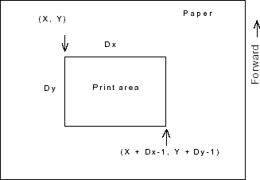

[Default value] xL = xH = yL = yH = 0

dxL, dxH, dyL and dyH are as follows under different print dot widths:

|  |  |  |
| --- | --- | --- |
| Print dot width | Number of dots in horizontal direction | Default value |
| 640 dots width | 640 dots | dxL = 128, dxH = 2, dyL = 220, dyH = 0 |
| 576 dots width | 576 dots | dxL = 64, dxH = 2,  dyL = 220, dyH = 0 |

[Reference] **CAN** , **ESC L** , **ESC T**

**Due to resource constraints, the default page size can only be 640x220. If you need a larger page, you need to modify the program or replace the SRAM larger MCU.**

ESC \ nL nH

[Name] Sets the relative print position

[Format] ASCII code ESC \ nL nH

Hexadecimal code 1B 5C nL nH

Decimal code 27 92 nL nH

[Scope] 0 ≤ nL≤255

0 ≤nH ≤ 255

[Description] Set the printing start position with the current position as the base point, using horizontal or vertical motion units.

This command sets the print position from the current position to a distance of [(nL + nH x 256) x 0.125 mm].

[Note]  Any settings that exceed the printable area are ignored.

When the distance n is specified to the right:

nL + nH x256 = N

When the distance *N* is specified to the left: (negative direction), Use the complement of 65536:

nL + nH x 256 = 65536 -N

In standard mode, use horizontal motion units.

In page mode, according to the starting point of the printing area, the difference between horizontal and vertical motion units is as follows:

① When the start position is set to the upper left or lower right corner with the **ESC T** command, the horizontal motion unit (x) is used.

② When the start position is set to the upper right or lower left corner with the **ESC T** command, the vertical motion unit (y) is used.

[Reference] **ESC $**

ESC a n

[Name] Select alignment

[Format] ASCII code ESC a n

Hexadecimal code 1B 61 n

Decimal code 27 97 n

[Scope] 0 ≤ n ≤2, 48 ≤ n ≤50

[Description] Aligns a row of data to the specified position

The following n is used to select alignment:

|  |  |
| --- | --- |
| n | alignment |
| 0, 48 | left alignment |
| 1, 49 | Centered |
| 2, 50 | right alignment |

[Note] • In standard mode, this command is valid only at the beginning of a line.

* + If this command is entered in page mode, the printer performs only internal flag operations.
  + This command is not valid for page mode.
  + This command performs alignment in the print area.

The command aligns the white space according to **HT** , **ESC $** or **ESC \** .

[Default value] n = 0

[Examples]

**left alignment Centered right alignment**

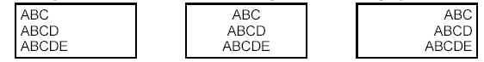

## ESC c 3 n

[Name] Select a printer paper sensor to output a paper shortage signal

[Format] ASCII code ESC c 3 n

Hexadecimal code 1B 63 33 n

Decimal code 27 99 51 n

[Scope] 0 ≤n ≤ 255

[Description] Select a printer paper sensor to output a paper shortage signal.

• The use of each bit of parameter n is shown in the following table:

|  |  |  |  |  |
| --- | --- | --- | --- | --- |
| Bit | Turn off/on | Hexadecimal | Decimalism | Function |
| 0 | Turn off | - | - | Undefined. |
| 1 | Turn off | 00 | 0 | Prohibit paper end sensor. |
| Turn on | 02 | 2 | Activate paper end sensor. |
| 2 | Turn off | - | - | Undefined. |
| 3 | Turn off | 00 | 0 | Prohibit paper end sensor. |
| Turn on | 08 | 8 | Activate paper end sensor. |
| 4-7 | - | - | - | Undefined. |

[Note] • Different program versions may have different support for this instruction, and the version actually used shall prevail.

Multiple sensors can be selected to output signals. In this case, if any of the sensors detects a paper shortage, it outputs a paper shortage signal.

This command is valid only for parallel interfaces and is ignored in serial interface mode.

[Default value] n = 0

## ESC c 4 n

[Name] Select the printer paper sensor to stop printing

[Format] ASCII code ESC c 4 n

Hexadecimal code 1B 63 34 n

Decimal code 27 99 52 n

[Scope] 0 ≤n≤255

[Description] When a paper shortage is detected, select the printer paper sensor to terminate the print. The parameter n is used as follows:

|  |  |  |  |  |
| --- | --- | --- | --- | --- |
| Bit | B | Hexadecimal | Decimalism | Function |
| 0 | Turn off | - | - | Undefined. |
| 1 | Turn off | 00 | 0 | Prohibit paper shortage sensor. |
| Turn on | 02 | 2 | Activate paper shortage sensor. |
| 2-7 | - | - | - | Undefined. |

[Note] • Different program versions may have different support for this instruction, and the version actually used shall prevail.

When a printer paper sensor is activated with this command, printing is stopped only when the corresponding printer paper is used.

When the paper end sensor detects the end of the printing paper, the printer stops printing and goes offline.

When bit 1 is on, the printer selects paper end sensor to stop printing.

[Default value] n = 0

This directive may vary from version to version.

ESC c 5 n

[Name] Activate / disable panel buttons

[Format] ASCII code ESC  c 5 n

Hexadecimal code 1B 63 35 n

Decimal code 27 99 53 n

[Scope] 0 ≤n≤255

[Description] Activate / disable panel buttons.

Activate the panel button when the minimum significant bit (LSB) of n is 0.

Disable the panel button when the minimum significant bit (LSB) of n is 1.

[Note] Different program versions may have different support for this instruction, and the version actually used shall prevail.

Only the least significant bit of n is used.

If the panel keys are disabled, none of the keys will work when turning off the printer machine head lever.

For this printer, the only panel key is the feed key.

[Default value] n = 0

ESC d n

[Name] Print and feed paper n line

[Format] ASCII code ESC d n

Hexadecimal code 1B 64 n

Decimal code 27 100 n

[Scope] 0 ≤ n ≤ 255

[Description] Print out the data in the print buffer and feed n lines.

[Note] This command sets the print start position as the line start point.

* + This command does not affect the line spacing set by the ESC 2 or ESC 3 commands.

[Reference] **ESC 2** , **ESC 3**

ESC t n

[Name] Select the character code table

[Format] ASCII code ESC t n

Hexadecimal code 1B 74 n

Decimal code 27 116 n

[Scope] 0≤ n≤5, 16 ≤ n ≤19, n = 255

[Description] Select page n from the character code table.

|  |  |
| --- | --- |
| n | Page |
| 0 | PC437 [American European Standard] |
| 1 | Katkana(katakana) |
| 2 | PC850 [Multiple Language] |
| 3 | PC860 [Portuguese] |
| 4 | PC863 [Canada-French] |
| 5 | PC865 [Northern Europe] |
| 16 | WPC1252 |
| 17 | PC866 [Slavic 2] |
| 18 | PC852 [Latin 2] |
| 19 | PC858 [Europe] |
| 36 | PC826(Hebrew) |

[Default value] n = 0

[Reference] Character table

ESC { n

[Name]  Set/unset reverse print mode

[Format] ASCII code ESC { n

Hexadecimal code 1B 7B n

Decimal code 27 123 n

[Scope] 0 ≤n ≤255

[Description] Set/unset reverse print mode.

When the LSB of n is 0, turn off the reverse print mode.

When the LSB of n is 1, turn on the reverse print mode.

[Note] Only the least significant digit of n is valid.

This command is valid only when entered at the beginning of a line in standard mode.

This command does not affect printing in page mode.

In reverse printing mode, the printer rotates the line to be printed by 180 ° before printing.

[Default value] n = 0

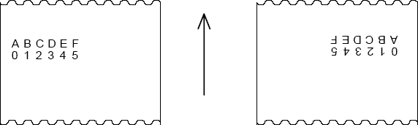[Examples]

解除颠倒打印模式 设置颠倒打印模式

Direction of the paper

## FS p n m

[ Name ] Print NV bitmap

[Format] ASCII code FS p n m

Hexadecimal code 1C 70 n m

Decimal code 28 112 n m

[Scope] 1 ≤n ≤ 255

0 ≤m≤3 , 48≤ m≤51

[Description] Print the NV bitmap *n* in the mode specified by m.

|  |  |  |  |
| --- | --- | --- | --- |
| m | Mode | Vertical point density | Horizontal point density |
| 0, 48 | Normal | 203.2 dpi | 203.2 dpi |
| 1, 49 | Double width | 203.2 dpi | 101.6 dpi |
| 2, 50 | Double height | 101.6 dpi | 203.2 dpi |
| 3, 51 | Four times the size | 101.6 dpi | 101.6 dpi |

dpi: Printing dots per 25.4 mm {1 inch}

n is the number of NV bitmaps(Define with **FS q** command).

m specifies the bitmap mode

[Detailed description] • NV bitmap is a kind of bitmap defined in nonvolatile memory. It is defined by **FS Q** and printed by **FS P**.

This command is invalid when the specified NV bitmap does not exist.

In standard mode, this command is valid only if there is no data in the print buffer.

In page mode, this command is invalid.

* + This command is not affected by print mode, except for reverse print mode（aggravation print，overlapping print，underline，character size，highlight print or 90 degree rotation of characters, etc.）.
  + If the width of the NV bitmap print area set with **GS L** and **GS W** is less than one vertical line, do the following only for the line in question. In NV bitmap mode, a vertical row means one dot in normal mode(m =0, 48) and one dot in double height mode(m =2, 50), two dots in double width mode(m =1, 49) and four times size mode(m =3, 51).

① In NV bitmap mode, the width of the print area extends to the right to one vertical line. In this case, the print does not exceed the print area.

② If the print area width does not extend a vertical line, the left margin is reduced to accommodate a vertical line.

If there is more than one line of the download bitmap to be printed, the excess data will not be printed.

* + In normal and double width mode, the command feeds n dots, n is the height of NV bitmap. In the double height and quadruple size modes, the command feeds 2n dots. n is the height of the NV bitmap, independent of the line spacing set by ESC 2 or ESC 3.

After printing the bitmap, the command sets the print position to the beginning of a line and processes the subsequent data as normal.

[Reference] **ESC \***, **FS q** , **GS /** , **GS v 0**

FS q n [xL xH yL yH d1...dk]1...[xL xH yL yH d1...dk]n [Name] Define the NV bitmap

[Format] ASCII code FS q n [xL xH yL yH d1...dk]1...[xL xH yL yH d1...dk]n

Hexadecimal code 1C 71 n [xL xH yL yH d1...dk]1...[xL xH yL yH d1...dk]n

Decimal code 28 113 n [xL xH yL yH d1...dk]1...[xL xH yL yH d1...dk]n

[Scope] 1≤ n ≤255

0≤xL ≤ 255

0 ≤ xH ≤3 ( When 1 ≤ (xL +xH X256) ≤1023

0 ≤yL ≤255

0≤ yH≤1 ( When 1 ≤ (yL +yH X 256) ≤288

0≤ d ≤ 255

k = (xL + xH X 256)X (yL+ yH X 256) ≤8

[Description] Define an NV bitmap with specific n values.

n specifies the number of defined NV bitmaps.

xL, xH specifies that the number of dots in the horizontal direction is (xL+ xH X 256) X 8 for the NV bitmap in the definition.

yL, yH specifies that the number of dots in the vertical direction is (yL +yH X 256) X 8 for the NV bitmap in the definition.

[Detailed description] The area that can be defined can reach 896k, and the data size of each bitmap can not exceed 16K. The software can download it continuously.

This command cancels all NV bitmaps that have been defined with this command. The printer cannot redefine any one of the defined series of data. If a data is redefined, all data must be sent again.

* + Mechanical operation cannot be performed from the beginning of processing this command to the completion of hardware reset（This includes initializing the print head position when the machine head level is open, and using the feed button to feed the paper）.
  + During this command processing, when writing data to the user NV memory, the printer is busy and stops receiving data. Therefore, the transmission of data, including real-time commands, is prohibited during the execution of this command.
  + NV bitmap is a kind of bitmap defined in nonvolatile memory. **FS P** printing is defined by **FS Q**.
  + In standard mode, this command is valid only at the beginning of a line.
  + In page mode, this command is invalid.
  + The command will not be valid until the 7 bytes <FSyH>of the command are processed properly.
  + When the amount of data exceeds the left capacity defined by xL, xH, yL, yH, the printer will process the range defined by XL, XH, YL, YH outside the defined range.
  + In the first set of bitmaps, when any parameter in xL, xH, yL, yH exceeds the defined range, the command is disabled.
  + In a group of bitmaps other than the first group, when the printer encounters that xL, xH, yL, yH are out of the defined range, it stops processing the command and starts writing NV images. At this point, NV bitmaps that have not been defined are prohibited (undefined), but any previously defined NV bitmaps are still valid.
  + d is the definition data. In data (d), a 1-bit specifies a point to be printed and a 0-bit specifies a point not to be printed.
  + This command defines n as the number of NV bitmaps. The number rises sequentially from bitmap 01H. Therefore, the first data group [xL xH yL yH d1...dk] is NV bitmap 01h, and the last data group [xL xH yL yH d1...dk] is NV bitmap n. The total number is consistent with the number of NV bitmaps set by the FS p command.
  + The definition data of an NV bitmap consists of [xL xH yL yH d1...dk]. Therefore, when there is only one NV bitmap, n =1, the printer only processes the data set [xL xH yL yH d1...dk] once. The printer uses ([data: (xL + xH X 256) X (yL + yH X 256) X 8] +[header :4]) bytes of NV memory.
  + Up to 70 bitmaps can be downloaded continuously with special software（Each bitmap data size does not exceed 16K。
  + Once a NV bitmap is defined, it cannot be deleted by executing the ESC @ command, resetting, and powering off.
  + This command only performs the definition of the NV bitmap, not the printing. The printing of NV bitmap is executed by FS p command.

[Note] Frequent execution of write commands may damage the NV memory.

Therefore, it is recommended to perform no more than 10 writes a day to NV memory.

[Reference] FS p

[Examples] 当 xL = 64, xH = 0, yL = 96, yH = 0

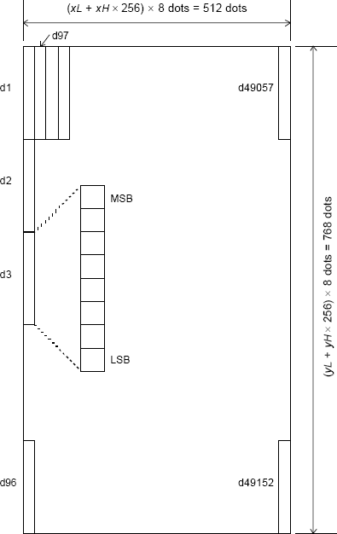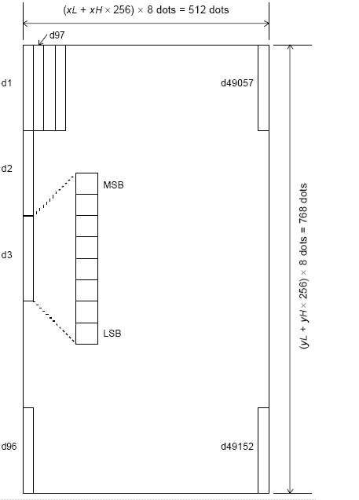

## GS FF

[Name] Put the black mark paper into the starting position of the print

[Format] ASCII code GS FF

Hexadecimal code 1D 0C

Decimal code 29 12

[Description] Feed the black mark paper into the starting position of the print.

[Note] The command is activated only if the BM sensor is set to be valid with DIP SW1-1.

This command sets the next print position at the beginning of a line.

Even if the command is executed at the printing start position of the black label printing paper, the printer does not feed the printing paper to the next printing start position.

[Reference] **GS ( F**, **FF**,

## GS ! n

[Name] Set character size

[Format] ASCII code GS ! n

Hexadecimal code 1D 21 n

Decimal code 29 33 n

[Scope] 0 ≤n≤ 255

(1 ≤Vertical multiple≤ 5, 1 ≤ Horizontal multiple ≤ 5)

|  |  |  |  |  |
| --- | --- | --- | --- | --- |
| Bit | Turn off/on | Hexadecimal | Decimalism | Function |
| 0 | Character height setting. Are shown in table 2. | | | |
| 1 |
| 2 |
| 3 |
| 4 | Character width setting. Are shown in table 1. | | | |
| 5 |
| 6 |
| 7 |

|  |  |  |
| --- | --- | --- |
| Hexadecimal | Decimalism | Width |
| 00 | 0 | 1(normal) |
| 10 | 16 | 2(double width) |
| 20 | 32 | 3 |
| 30 | 48 | 4 |
| 40 | 64 | Invalid |
| 50 | 80 | Invalid |
| 60 | 96 | Invalid |
| 70 | 112 | Invalid |

|  |  |  |
| --- | --- | --- |
| Hexadecimal | Decimalism | Width |
| 00 | 0 | 1(normal) |
| 01 | 1 | 2(double height) |
| 02 | 2 | 3 |
| 03 | 3 | 4 |
| 04 | 4 | 5 |
| 05 | 5 | 6 |
| 06 | 6 | 7 |
| 07 | 7 | Invalid |

[Description] Use 0 to 2 bits to set character height and 4 to 6 bits to set character width. As follows:

Table 2

Character height setting

Table 1 Character width setting

[Note] This command is valid for all characters （English, numeral characters and Chinese characters）except HRI characters.

* + If n is outside the defined scope, this command is ignored.
  + In standard mode, the vertical direction is the direction of the feed. However, when the character is rotated 90 degrees clockwise, the relationship between vertical and horizontal is reversed.
  + In page mode, vertical and horizontal directions are based on character orientation.
  + When characters are zoomed in on a line at different sizes, all characters in a line are aligned along the baseline.
  + ESC ! command can also be used to turn on or off the double width and double height mode. The Settings of the last command received are valid.

[Default value] n = 0

[Reference] **ESC !**

## GS $ nL nH

[Name] Set the absolute vertical print position in page mode

[Format] ASCII code GS $ nL nH

Hexadecimal code 1D 24 nL nH

Decimal code 29 36 nL nH

[Scope] 0≤nL ≤255, 0≤nH≤ 255

[Description] Set the absolute vertical printing start position for buffered data in page mode.

This command sets the absolute print position to [(nL + nH X256) X 0.125 mm].

[Note] This command only works in page mode.

This command is ignored if the [(nL + nH x 256) x (Unit of vertical or horizontal motion)] exceeds the specified print area.

The horizontal start buffer position does not move.

The reference starting position is specified by **ESC T**.

This command operates as follows, depending on the starting position of the print area set by ESC T：

① When the starting position is set at the top left or bottom right, the command sets the absolute position in the vertical direction.

② This command sets the absolute position in the horizontal direction when the starting position is set at the top right or bottom left.

[Reference] **ESC $** , **ESC T** , **ESC W** , **ESC \** , **GS \** ,

## GS ( F pL pH a m nL nH

[Name] Set the adjustment value

[Format] ASCII code GS ( F pL pH a m nL nH

Hexadecimal code 1D 28 46 pL pH a m nL nH

Decimal code 29 40 70 pL pH a m nL nH

[Scope] (pL + (pH X 256)) = 4 ( pL = 4, pH = 0)

1 ≤ a≤ 2

m = 0, 48 or 1, 49

0≤( nL + nH X 256) ≤1600

( 0 ≤ nL ≤ 255, 0 ≤nH ≤6)

[Description] This command is only valid if the BM sensor is allowed.

Sets the printer operation adjustment value specified by parameter A

The number of parameters specified by pL and pH is ‘a’ ～ (pL + (pH X256)) bytes.

a is used to specify the setting values of the starting printing position and cutting position.

|  |  |
| --- | --- |
| a | Function |
| 1 | Set the setting value of the starting printing position |
| 2 | Set the setting value of starting paper cutting position |

* + m specifies the direction of adjustment.

|  |  |
| --- | --- |
| m | Function |
| 0, 48 | Specifies the direction of forward feed |
| 1, 49 | Specifies the direction of reverse feed |

* + nL and nH specify the setting value is[(nL + nH X 256) X 0.125 mm].

Note： 1、When setting the starting paper cutting position, only m= 0,48 is supported, i.e., only forward feed is supported.

[Detailed description]

* + Print start position adjustment value (a = 1) is affected by the following command:

**FF , GS FF**

* + The paper cutting position adjustment value (a = 2) is affected by the following command:

**GS V m n**

* + The command is received from the host, first stored in the receive buffer, and then executed during the execution of other ordinary commands. As a result, the printer may delay execution of this command for some time after receiving it.The delay time depends on the state of the receive buffer.

See Appendix I for the setting method and detailed description of adjustment value of initial printing position and paper cutting position through **GS ( F.**

[Default value] All adjustment values are set to "0".

(When BM sensor detects BM, the corresponding positions of print head and cutter are printing start position and paper cutting position respectively.)

[Reference] **FF** , **GS FF** , **GS V**

GS * x y d1..d( x y 8 )

[Name] Define download bitmap

[Format] ASCII code GS * x y d1...d( x × y × 8 )

Hexadecimal code 1D 2A x y d1...d( x × y × 8 )

Decimal code 29 42 x y d1...d( x × y × 8 )

[Scope] 1≤ x ≤255

1 ≤ y≤ 48 (x X y ≤ 1536)

0 ≤ d≤255

[Description] Use x and y to specify the number of dots to define the download bitmap.

x specifies the number of dots in the horizontal direction.

y specifies dots in the vertical direction.

[Note] The number of dots in the horizontal direction is x × 8； The number of dots in the vertical direction is y ×8。

If x ×y exceeds the specified range, the command is disabled.

d represents bitmap data. Data (d) specifies that the print bit is 1 and the non print bit is 0.

Clear the download bitmap definition in the following cases：

① Execute **ESC @ .**

② Execute **ESC &** .

③ Printer reset or power off.

The relationship between the download bitmap and the print data is shown in the figure below.

[Reference] 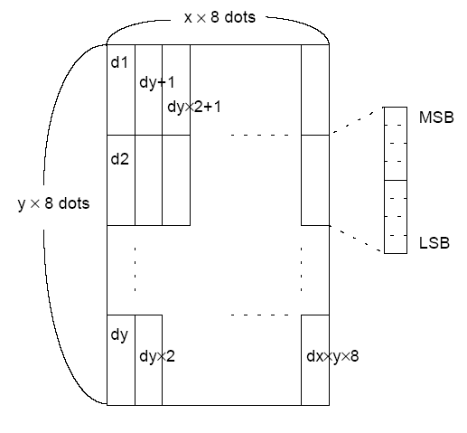

**GS /**

## GS / m

[Name] Print download bitmap

[Format] ASCII code GS / m

Hexadecimal code 1D 2F m

Decimal code 29 47 m

[Scope] 0≤m ≤ 3, 48 ≤ m ≤ 51

[Description] Print the download bitmap in the mode specified by m.

m set the mode from the table below：

|  |  |  |  |
| --- | --- | --- | --- |
| m | Mode | Vertical dot density | Horizontal dot density |
| 0, 48 | normal | 203.2 dpi | 203.2 dpi |
| 1, 49 | double width | 203.2 dpi | 101.6 dpi |
| 2, 50 | double height | 101.6 dpi | 203.2 dpi |
| 3, 51 | Four times the size | 101.6 dpi | 101.6 dpi |

dpi: Printing dots per 25.4 mm {1 inch}

[Note] If bitmap data is not defined, this command is ignored.

In standard mode, this command is only valid if there is no data in the print buffer.

This command is invalid in print mode[aggravation，overlapping，underline，character size or highlight print], except for reverse printing mode.

If the download bitmap to be printed exceeds the print area, the excess data will not be printed.

Page mode does not support download bitmap.

If the print area set by **GS L** and **GS W** is less than the width required for the data transferred by **GS/**command, perform the following subsequent operations on the line in question[Printing does not exceed the maximum printing area].

① The width of the print area is extended to the right to hold the amount of data.

② If step ① does not provide sufficient width for the data, the left margin is reduced to accommodate the data.

For each bit of data in normal mode (m = 0,48) and double height mode (m = 2, 50), the printer prints one dot；For each bit of data in double mode (m = 1, 49) and quadruple mode (m = 3, 51), the printer prints two dots.

[Reference] **GS \***

## GS B n

[Name]  Set/Unset highlight print mode

[Format] ASCII code GS B n

Hexadecimal code 1D 42 n

Decimal code 29 66 n

[Scope] 0 ≤n ≤255

[Description] Set/Unset highlight print mode.

When the LSB of n is 0, the highlight mode is turned off.

* + When the LSB of n is 1, the highlight mode turns on.

[Note] • Only the least significant digit of n is valid.

* + This command is valid for both built-in and user-defined characters.
  + When highlight mode is turned on, it also works with **ESC SP** Settings.
  + This command does not affect bitmaps, user-defined bitmaps, bar codes, HRI characters.
  + This command does not affect line spacing.
  + Highlight mode takes precedence over underline mode.

[Default value] n = 0

## GS H n

[Name] Select the print position of the HRI character

[Format] ASCII code GS H n

Hexadecimal code 1D 48 n

Decimal code 29 72 n

[Scope] 0 ≤ n ≤3, 48 ≤n ≤51

[Description] When printing bar codes, select the print position of the HRI characters.

n select the print position, as shown in the figure below:

|  |  |
| --- | --- |
| n | Print Position |
| 0, 48 | Not print |
| 1, 49 | Above the bar code |
| 2, 50 | Below the bar code |
| 3, 51 | Above and below the bar code |

**Note：The position at which the printer prints HRI characters is not placed in the standard position.**

HRI （Human Readable Interpretation） represents the character corresponding to a readable bar code.

[Note] • Print HRI characters using the fonts specified by **GS F**.

[Default value] n = 0

[Reference] **GS f**, **GS k**

## GS L nL nH

[Name] Set the left margin

[Format] ASCII code GS L nL nH

Hexadecimal code 1D 4C nL nH

Decimal code 29 76 nL nH

[Scope] 0 ≤nL≤ 255

0≤ nH ≤255

[Description] Set the left margin with nL and nH.

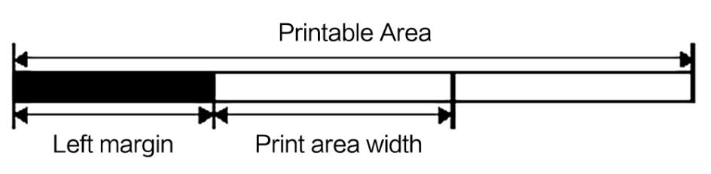The left margin is set to[(nL + nH X 256)  0.125 mm].

[Note] • In standard mode, this command is only valid if processed at the beginning of a line.

If this command is entered in page mode, the printer performs only internal flag operations.

* + If the setting is outside the printable range, the maximum printable unit is used.
  + When executing the raster bitmap command(**GS v 0** ), use this command to set the left margin in only 8 bits. If the amount of left margin you want to set is not divisible by 8, omit the remainder.

Examples) If (nL + nH  256) = 20, set the value to 16.

**Note：When used in combination with other features such as GS /, ESC *, etc., the print results may not be what you expect.**

[Default value] nL = 0, nH = 0

[Reference] **GS W**

①GS V m ②GS V m n [Name] Select the paper cutting mode and cut the paper

[Format] ①ASCII code GS V m

Hexadecimal code 1D 56 m

Decimal code 29 86 m

②ASCII code GS V m n

Hexadecimal code 1D 56 m n

Decimal code 29 86 m n

[Reference] **GS W**

[Scope] ① m = 1, 49

② m = 66, 0 ≤n≤255

[Description] Select a paper cutting mode and perform the paper cutting operation. The value of m is used to select the model, as shown below:

|  |  |
| --- | --- |
| m | Print Mode |
| 1,  49 | Part of the paper cutting (keep a little not cut) |
| 66 | When the black mark is invalid：Feed the paper to (Paper cutting position + [n  0.125 mm]) and partially cut the paper(keep a little not cut)，P type cutter.  When the black mark is valid, feed the paper to the cutting position and cut the paper partially (keep a little not cut)，P type cutter. |

[A detailed description of ① and ②]

* Depending on the type of automatic paper cutter installed, the paper cutting state is also different.
* The command is valid only when the command is processed at the beginning of a line.

[A detailed explanation of ①]

* Only part of the paper is cut；Not cut the paper completely.

[A detailed explanation of ②]

* When n = 0, the printer feeds the paper to the cutting position and cuts the paper.
* When n ≠ 0, the printer feeds the paper to (Paper cutting position + [n X 0.125 mm {0.0049 inch}]) and cuts the paper.
* When the black mark is valid, feed to (the value set by **GS ( F**).

## GS W nL nH

[Name] Set the print area width

[Format] ASCII code GS W nL nH

Hexadecimal code 1D 57 nL nH

Decimal code 29 87 nL nH

[Scope] 0 ≤nL≤ 255

0 ≤nH ≤ 255

[Description] nL and nH set the print area width.

* Set the print area width to [(nL + nH X 256) X 0.125 mm].

[Note] This command is valid only at the beginning of a line.

* If the command is entered in page mode, the printer performs an internal flag operation.
* This command does not affect printing in page mode.
* If the value is set beyond the printable range, use the maximum printable range.
* The setting priority of GS L is higher than the setting priority of GS W. If [left margin + Print area width] exceeds the printable area, the printer uses [Printable area width - left margin]. However, even if the settings made through GS W are not used in the current printing, the settings made through GS W will remain.
* If the width of the print area setting is smaller than the width of a character, when printing character data, the following processing is performed：

① The print area width is extended to the right to accommodate one character.

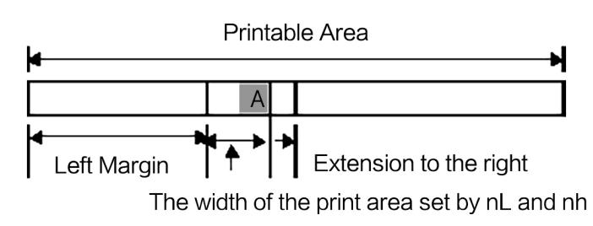

② If you cannot extend the print area sufficiently, reduce the left margin to fit one character.

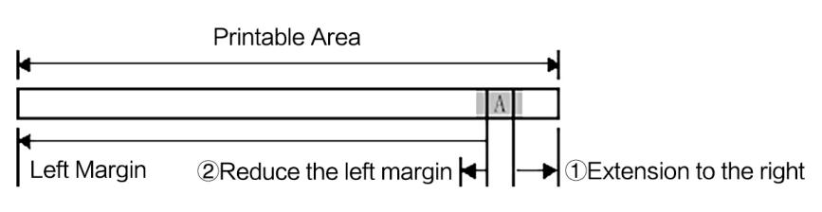

[Default value]

③ If the print area width is not sufficiently extended, reduce the right interval.

* If the width of the print area setting is less than that of a vertical line, when printing non character data(For example, bitmaps, user-defined bitmaps), only the lines with problems are treated as follows：

① Extend the print area width to the right to accommodate a vertical line of the bitmap within the printable area.

② If the width of the print area cannot be expanded sufficiently, reduce the left margin to fit a vertical line.

|  |  |  |
| --- | --- | --- |
| The mode type selected | Horizontal dots | Default value |
| 640 dots width | 640 dots | nL = 128, nH = 2 |
| 576 dots width | 576 dots | nL = 64, nH = 2 |

[Reference] **The description of the DIP.**

## GS \ nL nH

[Name] Set the relative vertical print position in page mode.

[Format] ASCII code GS \ nL nH

Hexadecimal code 1D 5C nL nH

Decimal code 29 92 nL nH

[Scope] 0 ≤ nL ≤255

0≤ nH ≤255

[Description] In page mode, set the relative vertical printing start position from the current position. This command sets the distance from the current position to [(nL + nH X256) X0.125 mm].

[Note] If page mode is not selected, ignore this command.

When N is specified as downward motion:

nL + nH X

When N is specified as moving upwards (in the negative direction), the complement of 65536 is used.

When N is specified as upward movement:

 nL + nH X - N

* Any settings that exceed the specified print area are ignored.
* According to the printing start position set by ESC T, the function of this command is as follows：

① The vertical motion unit (y) is used when setting the start position to the upper left or lower right of the print area.

② The horizontal motion unit (x) is used when setting the starting position to the upper right or lower left of the print area.

[Reference] **ESC $** , **ESC T** , **ESC W** , **ESC \** , **GS $**

GS a n

[Name] Allow to disable automatic status recovery(ASB)

[Format] ASCII code GS a n

Hexadecimal code 1D 61 n

Decimal code 29 97 n

[Scope] 0 ≤n≤255

[Description] Allow or disable ASB and specify included status items with n, as shown below:

|  |  |  |  |  |
| --- | --- | --- | --- | --- |
| Bit | Turn off/on | Hexadecimal code | Decimal code | ASB state |
| 0 | Turn off | 00 | 0 | Not fixed to turn off. |
| 1 | Turn off  Turn on | 00 | 0 | Online/offline status disabled. |
| 02 | 2 | Online/offline status is allowed. |
| 2 | Turn off  Turn on | 00 | 0 | Error status disabled. |
| 04 | 4 | Error status allowed. |
| 3 | Turn off  Turn on | 00 | 0 | Printing paper roll sensor status is forbidden. |
| 08 | 8 | Printing paper roll sensor status allowed. |
| 4 |  | - | - | Undefined. |
| 5 |  | - | - | Undefined. |
| 6 | Turn off  Turn on | 00 | 0 | Print paper FEED button is prohibited. |
| 40 | 64 | Print paper FEED button status allowed. |
| 7 | - | - | - | Undefined. |

[Note] • If any of the state items in the above table are allowed, the printer transmits the state when the command is executed. Once the allowed status item changes, the printer transmits the status automatically. Because each state transfer represents the current state, the prohibited state item can be changed.

* If all status items are disabled, the ASB function is also disabled.
* If ASB is allowed as the default setting, the printer transmits status the first time it can receive and transmit printer data from the printer.
* Transfer the following four status bytes without determining whether the host is ready to receive the data. The four status bytes must be contiguous, except for the XOFF code.
* Because the command data is executed after being processed in the receive buffer, there may be a lag time between the data receipt and the state transfer.
* When using DLE EOT or DLE EOT, it is necessary to distinguish between the status transmitted by these commands and the ASB state. According to Appendix C, the process in the identification of transmission status.According to Appendix C, the process in the identification of transmission status.
* The status items to transfer are as follows:

|  |  |  |  |  |
| --- | --- | --- | --- | --- |
| Bit | Turn off/on | Hexadecimal code | Decimal code | ASB state |
| 0 | Turn off | 00 | 0 | No need to use it. Fixed is off. |
| 1 | Turn off | 00 | 0 | No need to use it. Fixed is off. |
| 2 | Turn on | 04 | 4 | Undefined. Fixed is on. |
| 3 | Turn off | 00 | 0 | On-line. |
| Turn on | 08 | 8 | Off-line. |
| 4 | Turn on | 10 | 16 | No need to use it. Fixed is on. |
| 5 | Turn off | 00 | 0 | Close the machine head level. |
| Turn on | 20 | 32 | Open the machine head level. |

First byte (Printer information)

|  |  |  |  |  |
| --- | --- | --- | --- | --- |
| 6 | Turn off | 00 | 0 | The paper cannot be fed by using the print paper FEED button. |
| Turn on | 40 | 64 | The paper can be fed by using the print paper FEED button. |
| 7 | Turn off | 00 | 0 | No need to use it. Fixed is off. |

Second byte (Printer information)

|  |  |  |  |  |
| --- | --- | --- | --- | --- |
| Bit | Turn off/on | Hexadecimal code | Decimal code | ASB state |
| 0 | Turn off | 00 | 0 | Non-online waiting state. |
| Turn on | 01 | 1 | Online waiting state. |
| 1 | Turn off | 00 | 0 | Turn off the printer paper FEED switch. |
| Turn on | 02 | 2 | Turn on the printer paper FEED switch. |
| 2 | Turn off | 00 | 0 | No mechanical errors. |
| Turn on | 04 | 4 | Mechanical errors have occurred. |
| 3 | Turn off | 00 | 0 | No automatic paper cutting error. |
| Turn on | 08 | 8 | Automatic paper cutting error has occurred. |
| 4 | Turn off | 00 | 0 | No need to use it. Fixed is off. |
| 5 | Turn off | 00 | 0 | There are no unrecoverable errors. |
| Turn on | 20 | 32 | Unrecoverable error occurs. |
| 6 | Turn off | 00 | 0 | No automatic recovery error. |
| Turn on | 40 | 64 | Can automatically recover from errors. |
| 7 | Turn off | 00 | 0 | Not use. Fixed is off. |

Bit 0： See **DLE EOT** related explanation.

Bit 2： See **DLE EOT** related explanation.

位 6: When printing is stopped due to high head temperature, bit 6 is ON (ON) until the head temperature drops low enough or the cover of the paper roll is opened during printing.

Print recovery, Bit 6 becomes OFF （Turn off）.

Third byte (Printer paper sensor information)

|  |  |  |  |  |
| --- | --- | --- | --- | --- |
| Bit | Turn off/Turn on | Hexadecimal code | Decimal code | ASB state |
| 0,  1 | Turn off | 00 | 0 | Paper end sensor： Enough printing paper. |
| Turn on | 03 | 3 | Paper end sensor： The printing paper is running out. |
| 2,  3 | Turn off | 00 | 0 | Paper end sensor： Printer paper exists. |
| Turn on | 0C | 12 | Paper end sensor： Printer paper does not exist. |
| 4 | Turn off | 00 | 0 | Not use. Fixed is off. |
| 5,  6 | - | - | - | Undefined. |
| 7 | Turn off | 00 | 0 | Not use. Fixed is off. |

第FoFourth byte (Printer paper sensor information)

|  |  |  |  |  |
| --- | --- | --- | --- | --- |
| Bit | Turn off/on | Hexadecimal code | Decimal code | ASB state |
| 0-3 | - | - | - | Undefined. |
| 4 | Turn off | 00 | 0 | Not use. Fixed is off. |
| 5,  6 | - | - | - | Undefined. |
| 7 | Turn off | 00 | 0 | Not use.Fixed is off. |

[Reference] **DLE EOT** , **GS r**

GS f n

[Name] Choose the HRI （Human Readable Interpretation ）character font

[Format] ASCII code GS f n

Hexadecimal code 1D 66 n

Decimal code 29 102 n

[Scope] n =0, 1, 48, 49

[Description] Select a font for the HRI character used when printing a bar code.

n is used to select a font as shown below

|  |  |
| --- | --- |
| N | Font |
| 0, 48 | Font A (12  24) |
| 1, 49 | Font B (9  17) |

[Note] • HRI Human Readable Interpretation means the corresponding character of the Readable bar code.

Print HRI characters at the position specified by GS H.

[Default value] n = 0

[Reference] **GS H** , **GS k**

## GS h n

[Name] Set bar code height

[Format] ASCII code GS h n

Hexadecimal code 1D 68 n

Decimal code 29 104 n

[Scope] 1 ≤n≤255

[Description] Set bar code height

n sets the number of dots in the vertical direction

For PDF417 bar code printing, this value will be changed according to the actual calculated height, and the value divided by GS W is set to get the number of PDF417 columns that can be printed by dividing by 4.

[Default value] n = 162

[Reference] **GS k**

①GS k m d1 . dk NUL ②GS k m n d1 . dn

[Name] Print bar code

[Format] ①ASCII code GS k m d1 ... dk NUL

⒈ASCII code GS k m row column d1...dk NUL

Hexadecimal code 1D 6B m d1... dk 00

Decimal code 29 107 m d1... dk 0

②ASCII code GS k m n d1...dn

⒉ASCII code GS k m row column n d1...dn

Hexadecimal code 1D 6B m n d1...dn

Decimal code 29 107 m n d1...dn

[Scope] ① 0≤m ≤9 (k and d depend on the bar code system used)

② 65≤ m ≤ 76 (n and d depend on the bar code system used)

[Description] Select the bar code system and print the bar code.

m select the bar code system as follows

|  |  |  |  |  |
| --- | --- | --- | --- | --- |
| m | | Bar code system | The number of characters | Notes |
| ① | 0 | UPC-A | 11 ≤ k ≤ 12 | 48 ≤ d ≤57 |
| 1 | UPC-E | 11 ≤ k ≤12 | 48≤ d ≤ 57 |
| 2 | JAN13 (EAN13) | 12 ≤ k ≤ 13 | 48 ≤d ≤ 57 |
| 3 | JAN8 (EAN8) | 7 ≤ k ≤ 8 | 48 ≤ d ≤ 57 |
| 4 | CODE39 | 1 ≤k | 48≤d ≤57, 65≤ d ≤ 90, 32,  36, 37, 43, 45, 46, 47 |
| 5 | ITF | 1 ≤ k (K is even) | 48 ≤ d ≤ 57 |

|  |  |  |  |  |
| --- | --- | --- | --- | --- |
|  | 6 | CODABAR | 1 ≤ k | 48 ≤d ≤ 57, 65 ≤ d≤68, 36,  43, 45, 46, 47, 58 |
| 7 | Standard EAN13 | 12≤ k ≤ 13 | 48 ≤d ≤57 |
| 8 | Standard EAN8 | 7≤ k ≤8 | 48≤ d ≤ 57 |
| 9 | PDF417 | 1≤ k ≤ 255 | 0 ≤d ≤ 255 |
| ② | 65 | UPC-A | 11 ≤ n ≤12 | 48 ≤ d ≤57 |
| 66 | UPC-E | 11≤ n ≤ 12 | 48≤ d ≤ 57 |
| 67 | JAN13 (EAN13) | 12≤n ≤ 13 | 48 ≤ d ≤ 57 |
| 68 | JAN8 (EAN8) | 7 ≤n ≤ 8 | 48 ≤ d ≤57 |
| 69 | CODE39 | 1 ≤n≤ 255 | 48 ≤d ≤57, 65 ≤ d≤90, 32,  36, 37, 43, 45, 46, 47 |
| 70 | ITF | 1≤ n≤ 255 (n is even) | 48 ≤ d ≤ 57 |
| 71 | CODABAR | 1 ≤ n ≤ 255 | 48 ≤d ≤ 57, 65 ≤ d ≤ 68, 36,  43, 45, 46, 47, 58 |
| 72 | CODE93 | 1≤ n ≤255 | 0 ≤d ≤ 127 |
| 73 | CODE128 | 1 ≤ n≤ 255 | 0≤d ≤127 |
| 74 | Standard EAN13 | 12 ≤n ≤13 | 48 ≤ d ≤ 57 |
| 75 | Standard EAN8 | 7≤ n ≤ 8 | 48 ≤d ≤57 |
| 76 | PDF417 | 1≤ n ≤ 255 | 0≤d ≤255 |

[Note ①]

* This command is terminated by the NUL code.
* When the bar code system used is UPC-A or UPC-E, the printer receives 12 bytes of bar code data, prints the bar code and processes the subsequent data as normal data.
* When the bar code system used is JAN13 (EAN13), the printer receives 13 bytes of bar code data, prints the bar code and processes the subsequent data as normal data.
* When the bar code system used is JAN8 (EAN8), the printer receives 8 bytes of bar code data and prints the bar code and processes the subsequent data as normal data.
* The number of ITF bar code data must be an even number. When an odd number of data is entered, the printer ignores the last data received.

⒈The PDF417 bar code command adds row and column parameters. Row parameter ranges from 0,3-90, colum parameter 0, 1-printable maximum, which is adjusted according to the head setting and bar code width. If row is equal to 0 and column is equal to 0, adjust the height（See the GS h command） and width（See the GS w command） of the bar code.

[Note ②]

* n specifies the number of bytes of barcode data, and the printer processes n bytes of data as barcode data starting with the next character.
* If n exceeds the specified range, the printer stops processing the command and processes the subsequent data as normal
* ⒉The PDF417 barcode command adds row and column parameters. The value range is the same as that in⒈

[Notes in standard mode]

If d is outside the specified range, the printer simply feeds the paper and processes the subsequent data as normal.

If the horizontal dimension is beyond the print area, the printer is simply feeding paper.

This command feeds the paper as required to print the barcode, regardless of the line spacing set by E∑X2 or E∑X3. .

This command is valid only if there is no data in the print buffer. When there is data in the print buffer, the printer processes the subsequent data of m as normal data.

After printing the barcode, this command sets the print position to the beginning of a line.

The command is not affected by the printing mode (bold, overlap, underline, character size, highlight printing, or character 90 degree rotation, etc.), except reverse printing mode.

PDF417 bar code printing function optional parameters are row, column, and does not support error level configuration. The error level is automatically adjusted according to the configured row, column. If the computed PDF417 code word is 10,row*column=30, then the error level is automatically adjusted to level 4

[Note in page mode]

* + This command generates bar code data in the print buffer, but does not print. After processing the bar code data, the command moves the print position to the right point of the bar code.
  + If d exceeds the specified range, the printer stop command processes the subsequent data as normal. In this case, the data buffer location remains the same.
  + If the bar code width exceeds the print area, the printer does not print the bar code, but moves the data buffer position to the left outside the print area.
  + PDF417 bar code printing function is not supported in page mode.
  + See Section 3.9, Page mode.

When using a thermal label：

* + If the bar code height does not fit the current label, the excess section is printed on the next label.

When using CODE93 (m = 72)：

* + The printer prints an HRI character(□) at the beginning of the HRI string as the starting character of the HRI string.
  + The printer prints an HRI character (□)at the end of the HRI string as the termination character of the HRI string.
  + The printer prints HRI characters (■ + A literal character)as control characters(<00>H to <1F>H and<7F>H)：

|  |  |  |  |  |  |  |  |
| --- | --- | --- | --- | --- | --- | --- | --- |
| Control character | | | HRI  character | Control character | | | HRI character |
| ASCII code | Hexadecimal | Decimalism | ASCII code | Hexadecimal | Decimalism |
| NUL | 00 | 0 | * U | DLE | 10 | 16 | * P |
| SOH | 01 | 1 | * A | DC1 | 11 | 17 | * Q |
| STX | 02 | 2 | * B | DC2 | 12 | 18 | * R |
| ETX | 03 | 3 | * C | DC3 | 13 | 19 | * S |
| EOT | 04 | 4 | * D | DC4 | 14 | 20 | * T |
| ENQ | 05 | 5 | * E | NAK | 15 | 21 | * U |
| ACK | 06 | 6 | * F | SYN | 16 | 22 | * V |
| BEL | 07 | 7 | * G | ETB | 17 | 23 | * W |
| BS | 08 | 8 | * H | CAN | 18 | 24 | * X |
| HT | 09 | 9 | * I | EN | 19 | 25 | * Y |
| LF | 0A | 10 | * J | SUB | 1A | 26 | * Z |
| VT | 0B | 11 | * K | ESC | 1B | 27 | * A |
| FF | 0C | 12 | * L | FS | 1C | 28 | * B |
| CR | 0D | 13 | * M | GS | 1D | 29 | * C |
| SO | 0E | 14 | * N | RS | 1E | 30 | * D |
| SI | 0F | 15 | * O | US | 1F | 31 | * E |
|  | | | | DEL | 7F | 127 | * T |

[ Example ] print GS k 72 7 67 111 100 101 13 57 51



When using CODE128 (m = 73) ：

* For information about CODE128 bar codes and their code tables, see Appendix E.
* When using CODE128 for this printer, consider the following factors regarding data transfer：

①The header of the bar code data string must be an encoding set selection character(CODE A, CODE B, or CODE C) to select the first encoding set to be used.

②Use the character "{" and a character combination to define special characters. Define the ASCII character "{" by transmitting "{" twice in succession.

|  |  |  |  |
| --- | --- | --- | --- |
| Special character | Transmit data | | |
| ASCII code | Hexadecimal | Decimalism |
| SHIFT | {S | 7B,53 | 123,83 |
| CODE A | {A | 7B,41 | 123,65 |
| CODE B | {B | 7B,42 | 123,66 |
| CODE C | {C | 7B,43 | 123,67 |
| FNC1 | {1 | 7B,31 | 123,49 |
| FNC2 | {2 | 7B,32 | 123,50 |

|  |  |  |  |
| --- | --- | --- | --- |
| FNC3 | {3 | 7B,33 | 123,51 |
| FNC4 | {4 | 7B,34 | 123,52 |
| “{” | {{ | 7B,7B | 123,123 |

[Examples] Print instance data for"No. 123456"

In this example, the printer first prints "No." with code B, and then prints the following numbers with code C.

**GS k** 73 10 123 66 78 111 46 123 67 12 34 56



* If the header of the data string of the bar code is not an encoding set selection character, the printer stops processing the command and treats the subsequent data as normal data.
* If the combination of "{" and subsequent characters does not apply to any special characters, the printer stops command processing and processes subsequent data as normal data.
* If the printer receives a character that cannot be used for a particular encoding set, the printer stops the processing command and processes the subsequent data as normal data.
* The printer does not print HRI characters corresponding to shift characters or encoding set selection characters.
* The HRI character for a function character is a space.
* The HRI characters for the control characters (<00>H to <1F>H and <7F>H) are spaces.

<Other> Be sure to leave space between left and right bar codes.（The spacing varies according to the type of bar code）

[Reference] **GS H**, **GS f**, **GS h**, **GS w**，Appendix E

## GS r n

[Name] Transfer state

[Format] ASCII code GS r n

Hexadecimal code 1D 72 n

Decimal code 29 114 n

[Scope] n = 1, 49

[Description]  The state n specified by N is transmitted as follows：

|  |  |
| --- | --- |
| N | Function |
| 1,49 | Transmit the printer paper sensor status |

[Note] • This command is executed when the data is generated in the print buffer. Therefore, depending on the state of the receive buffer, there may be a time interval between receiving the command and sending status.

When automatic state recovery (ASB) is activated with GS a, the states transmitted with GS r and ASB states must be distinguished by the table in Appendix C.

The types of states transmitted are as follows:

Printer paper sensor status(n = 1, 49)

|  |  |  |  |  |
| --- | --- | --- | --- | --- |
| Bit | Turn off/on | Hexadecimal | Decimalism | ASB state |
| 0，1 | Turn off | 00 | 0 | Paper end sensor：Enough paper. |
| Turn on | 03 | 3 | Paper end sensor：The printing paper is running out。 |
| 2，3 | Turn off | 00 | 0 | Paper end sensor：Enough paper。 |
| Turn on | （0C） | （12） | Paper end sensor：Paper end。 |
| 4 | Turn off | 00 | 0 | Not use. Fixed is off. |
| 5，6 | - | - | - | Undefined. |
| 7 | Turn on | 00 | 0 | Not use. Fixed is off. |

Bit2 and3: When the printing paper end sensor detects the printing paper end, the printer goes offline and the command is not executed. Therefore, bits 2 and 3 do not transmit the paperless state.。

[Reference] **DLE EOT**, **GS a**, Appendix C

## GS v 0 m xL xH yL yH d1 ... dk

[Name] Print raster bitmap

[Format] ASCII code GS v 0 m xL xH yL yH d1...dk

Hexadecimal code 1D 76 30 m xL xH yL yH d1...dk

Decimal code 29 118 48 m xL xH yL yH d1...dk

[Scope] 0 ≤m ≤ 3, 48≤m≤51

0 ≤xL ≤255

0 ≤ xH ≤ 255 1 ≤ (xL + xH X 256)≤ 128

0≤yL≤255

0 ≤ yH≤ 8 1≤(yL + yH X 256) ≤4095

0 ≤d ≤255

k = (xL + xH × 256)  (yL + yH ×256) (k ≠ 0)

[Description] The setting mode of m value of raster bitmap is as follows:

|  |  |  |  |
| --- | --- | --- | --- |
| m | Mode | Vertical dot density | Horizontal dot density |
| 0, 48 | normal | 203.2 dpi | 203.2 dpi |
| 1, 49 | double width | 203.2 dpi | 101.6 dpi |
| 2, 50 | double height | 101.6 dpi | 203.2 dpi |
| 3, 51 | Four times the size | 101.6 dpi | 101.6 dpi |

(dpi: Print dots per 25.4 mm {1 inch})

* xL, xH,Sets the number of bytes of data in the horizontal direction of the bitmap(xL+xH×256)。
* yL, yH, Sets the number of bytes of data in the vertical direction of the bitmap(yL+yH×256)。

[Note] •  In standard mode, this command is only valid if there is no data in the print buffer.

* For raster bitmap printing, this command is not affected by the print mode(Character size, aggravation, overlap, reverse print, underline, highlight print, etc).
* If the print area width set by GS L and GS W is less than the minimum width, the printer will only extend the line in question to the minimum width. The minimum width is one dot for normal(m=0, 48) and double height(m=2, 50) modes, and two dots for double width(m=1, 49) and quadruple size (m=3, 51)modes.
* Data outside the print area is read in and discarded dot by dot.
* If the print position of subsequent characters is a multiple of 8. The subsequent print positions of the characters to be printed as raster bitmaps are set by **HT** (horizontal TAB) **ESC $**(set absolute print position),**ESC \** (set relative print position) and GS L(set left margin)
* **ESC a** (set alignment) Settings are also available for raster bitmaps.
* When the command is received during a macro definition, the printer ends the macro definition and starts executing the command to clear the definition of the command.
* d indicates bitmap data. The dot to print is set to 1, and the dot not to print is set to 0.

[Examples] When xL+xH×256=64

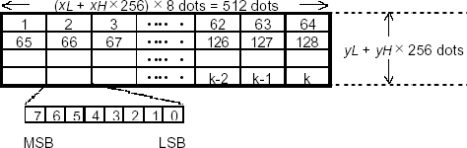

## GS w n

[Name] Set bar code width

[Format] ASCII code GS w n

Hexadecimal code 1D 77 n

Decimal code 29 119 n

[Scope] 2 ≤ n ≤6

[Default value] n = 3 [Reference] **GS k**

* 1. Chinese character control command

## FS ! n

[Name] Set Chinese character printing mode combination

[Format] ASCII code FS ! n

Hexadecimal code 1C 21 n

Decimal code 28 33 n

[Scope] 0≤ n≤255

[Description] Set the Chinese character printing mode. The setting of n is as follows:

|  |  |  |  |  |
| --- | --- | --- | --- | --- |
| Bit | Turn off/on | Hexadecimal code | Decimal code | Function |
| 0 | - | - | - | Undefined |
| 1 | - | - | - | Undefined |
| 2 | Turn off | 00 | 0 | Disable double width mode |
| Turn on | 04 | 4 | Allow double width mode |
| 3 | Turn off | 00 | . | Disable double height mode |
| Turn on | 08 | 8 | Allow double height mode |
| 4 | - | - | - | Undefined |
| 5 | - | - | - | Undefined |
| 6 | - | - | - | Undefined |
| 7 | Turn off | 00 | 0 | Disable underline mode |
| Turn on | 08 | 128 | Allow underline mode |

[Detailed description] • When the width and height modes are set at the same time (including the right and left character spacing), characters of four times the size are printed.

* + - The printer can underline all characters (including the right and left character spacing), but cannot underline the spaces set by the **HT** command and the characters rotated 90 ° clockwise.
    - The width of the underline is specified by **FS** -. It is independent of the character size.
    - When some characters in a line are multiple or higher, all characters in the line are aligned along the baseline.
    - The **FS W** or **GS !** command can be used to scribble Chinese characters, and the settings of the last received command are valid
    - You can use the **FS -** command to set or cancel underline mode. The settings of the last command received are valid.

[Default value] n = 0

[Reference] **FS -**, **FS W** , **GS !**

## FS &

[Name] Set Chinese character mode

[Format] ASCII code FS &

Hexadecimal code 1C 26

Decimal code 28 38

[Description] Select Chinese character mode.

[Detailed description] • This command is only valid if the GB18030 coding system is selected.

• GB1 80 30 only supports double byte 1、2、3、4、5area.

When selecting Chinese character mode, the printer processes all Chinese character codes, two bytes at a time.

The Chinese character code is processed in the order of the first byte and the second byte.

When the power is turned on, the printer will enter the Chinese character mode automatically.

When selecting Chinese character mode, the printer first checks whether the code is Chinese character；If it is a Chinese character, the first byte and the second byte of the Chinese character code are processed.

[Reference] **FS .**，**FS C**

## FS – n

[Name] Sets/cancels Chinese character underline mode

[Format] ASCII code FS - n

Hexadecimal code 1C 2D n

Decimal code 28 45 n

[Scope] 0 ≤ n ≤ 2, 48 ≤ n ≤ 50

[Description] ·For receipts and attachments, set or cancel the Chinese character underline mode based on the following n values.

|  |  |
| --- | --- |
| n | Function |
| 0, 48 | Cancel Chinese character underline mode |
| 1, 49 | Sets Chinese character underline mode (1-dot width) |
| 2, 50 | Sets Chinese character underline mode (2-dot width) |

[Detailed description] • The printer can underline all characters (including right and left character spacing), but not the Spaces set by the HT command, as well as the clockwise 90° character.

* By setting n to 0, underline printing will no longer be performed after the Character underline is canceled, but the previously specified underline width remains the same. The default underline width is 1 dot.
* The specified underline width remains the same even if the character size changes.
* You can use FS ! to set or cancel the underline mode, and the last command received is valid.

[Default value] n =0

[Reference] **FS !**

## FS .

[Name] Cancel Chinese character

[Format] ASCII code FS .

Hexadecimal code 1C 2E

Decimal code 28 46

[Description] Cancel Chinese character mode

[Detailed description] • This command is only valid if the GB18030 coding system is selected.

* When Chinese character mode is not selected, all character codes are treated as ASCII codes, one character at a time.
* When the power is turned on, the printer automatically enters the Chinese character mode.
* When Chinese character mode is not selected, all character codes are treated as ASCII codes, one character at a time.

[Reference] **FS &**, **FS C**

FS 2 [c11 c12 d1...d1k]1 … [cn1 cn2 d1...dnk]n NULL [Name] Define user-defined Chinese characters

[Format] ASCII code FS 2 [c11 c12 d1...d1k]1 … [cn1 cn2 d1...dnk]n NUL

Hexadecimal code 1C 32 [c11 c12 d1...d1k]1 … [cn1 cn2 d1...dnk]n 00

Decimal code 28 50 [c11 c12 d1...d1k]1 … [cn1 cn2 d1...dnk]n 0

[Scope]  c1 and c2 are the zone bit codes in the user-defined Chinese character area determined by **FS C** ，k=72，n is the number of characters to be defined，d1…dk is user-defined Chinese character data. Zone bit codes that are not in the selected user-defined Character area will be considered invalid.

[Description] c1 is zone code, c2 is the bit code. User-defined Characters are saved in FLASH and are not lost after power failure.

* Before using FS 2 command to customize Chinese characters, the code area must be determined.(Use the FS C command. See the FS C command instructions for details.)
* After sending FS 2 [c11 c12 d1...d1k]1 … [cn1 cn2 d1 dnk]n，nul is sent to end the definition.
* Repeatedly [note]defining characters can damage FLASH MEMORY. Less than 10 times a day is recommended.
* Define multiple Chinese characters, complete with one command, that is, centralized definition.
* This command is valid when the print position is at the beginning of the line.

[Detailed description] This command can define n characters at a time, after sending FS 2 [c11 c12 d1...d1k]1 … [cn1 cn2 d1 dnk]n ，finally NUL(value 0) is sent to end the definition. According to this command, you can define all characters in the user-defined area code range. Duplicate definition means that the same location code of the selected user-defined area bit range is defined more than twice.

Different program versions may have different support for this instruction, and the version actually used shall prevail.

[Default value] All spaces

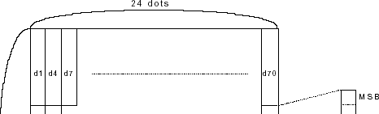[Reference] **FS C**

[Examples]

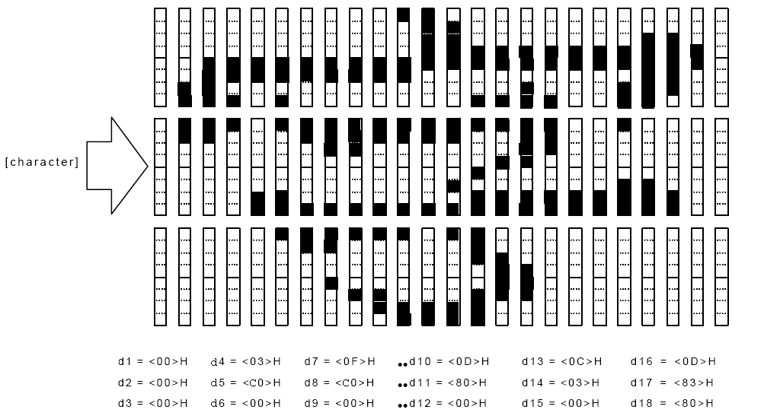

## FS S n 1 n 2

[Name] Set the space between left and right characters

[Format] ASCII code FS S n1 n2

Hexadecimal code 1C 53 n1 n2

Decimal code 28 83 n1 n2

[Scope] 0 ≤ n1 ≤255

0 ≤ n2 ≤ 255

[Description] Set the character spacing of the left and right Chinese characters to n1 and n2 respectively.

* + Character spacing on the left is [n1× 0.125 mm], Character spacing on the right is [n2× 0.125 mm].

[Detailed description] • This command sets the left and right character spacing for normal size characters. When set to double width mode, the character spacing on the left and right is twice that in normal mode.

* + You can use this command to set the spacing in standard mode and page mode respectively.
  + In standard mode, use horizontal motion units.
  + In page mode, the use of horizontal or vertical motion units varies depending on the page mode, depending on the starting position of the printable area. As shown below:

①The horizontal motion unit (x) is used when **ESC T** is used to set the starting position to the upper left or lower right corner of the printable area.

②When **ESC T** is used to set the starting position to the upper right or lower left of the printable area, the vertical motion unit (y) is used.

[Default value] n1 = 0, n2 = 0

FS W n

[Name]  Set/unset quadruple mode Chinese print

[Format] ASCII code FS W n

Hexadecimal code 1C 57 n

Decimal code 28 87 n

[Scope] 0 ≤ n ≤ 255

[Description] Set/unset quadruple mode Chinese print.

* When LSB of n is 0, the quadruple mode of Chinese characters is removed.
* When LSB of n is 1, the quadruple mode of Chinese characters is set.

[Detailed description] • Only the least significant digit of n is valid.

* In quadruple mode, the character size printed is the same as when the double width and double height modes are set simultaneously
* When you use this command to cancel quadruple mode, the characters will be printed according to the size of ordinary characters.
* Some characters in a line have different heights, and all characters in that line are aligned against the baseline.
* When a character is enlarged horizontally, it is enlarged to the right, based on the left side of the character.
* You can also use **FS !** or **GS !** to set/unset the last command received in the quad mode by selecting the double width and double height modes.

[Default value] n = 0

[Reference] **FS ！**， **GS ！**

# 

## CODE128 bar code

**CODE128 Bar code description**

In the CODE128 system, a bar code character set can represent 128 ASCII characters and 2-digit Numbers. These bar code characters are defined by 103 bar code characters and 3 code sets. Each code set is used to represent the following characters:

* Code Set A ：ASCII character 00H to 5FH
* Code Set B: ASCII character 20H to 7FH
* Code Set C: 2-digit natural numeric character represented by one character (100 digits from 00 to 99)

There are also the following special characters in CODE128:

* SHIFT character

In code set A, the code immediately after SHIFT is treated as a character of code B. In code set B, the code immediately after SHIFT is treated as a character in code set A. The shift character cannot be used with code set C.

* Code set selects characters (CODE A, CODE B, CODE C)

This character converts the subsequent code set to code set A, B or C

* Function character (FNC1, FNC2, FNC3, FNC4)

The use of function characters depends on the application.In code set C, only FNC1 is available.

**Code table**

**Printable characters in code set A**

|  |  |  |  |  |  |  |  |  |
| --- | --- | --- | --- | --- | --- | --- | --- | --- |
| Character | Transmit data | | Character | Transmit data | | Character | Transmit data | |
| Hexadecimal | Decimalism | Hexadecimal | Decimalism |  | Hexadecimal | Decimalism |
| NUL | 00 | 0 | ( | 28 | 40 | P | 50 | 80 |
| SOH | 01 | 1 | ) | 29 | 41 | Q | 51 | 81 |
| STX | 02 | 2 | * | 2A | 42 | R | 52 | 82 |
| ETX | 03 | 3 | + | 2B | 43 | S | 53 | 83 |
| EOT | 04 | 4 | , | 2C | 44 | T | 54 | 84 |
| ENQ | 05 | 5 | - | 2D | 45 | U | 55 | 85 |
| ACK | 06 | 6 | . | 2E | 46 | V | 56 | 86 |
| BEL | 07 | 7 | / | 2F | 47 | W | 57 | 87 |
| BS | 08 | 8 | 0 | 30 | 48 | X | 58 | 88 |
| T | 09 | 9 | 1 | 31 | 49 | Y | 59 | 89 |
| LF | 0A | 10 | 2 | 32 | 50 | Z | 5A | 90 |
| VT | 0B | 11 | 3 | 33 | 51 | [ | 5B | 91 |
| FF | 0C | 12 | 4 | 34 | 52 | \ | 5C | 92 |
| CR | 0D | 13 | 5 | 35 | 53 | ] | 5D | 93 |
| SO | 0E | 14 | 6 | 36 | 54 | ^ | 5E | 94 |
| SI | 0F | 15 | 7 | 37 | 55 | _ | 5F | 95 |
| DLE | 10 | 16 | 8 | 38 | 56 | FNC1 | 7B, 31 | 123,49 |
| DC1 | 11 | 17 | 9 | 39 | 57 | FNC2 | 7B,32 | 123,50 |
| DC2 | 12 | 18 | : | 3A | 58 | FNC3 | 7B,33 | 123,51 |
| DC3 | 13 | 19 | ; | 3B | 59 | FNC4 | 7B,34 | 123,52 |
| DC4 | 14 | 20 | < | 3C | 60 | SHIFT | 7B,53 | 123,83 |
| NAK | 15 | 21 | = | 3D | 61 | CODEB | 7B,42 | 123,66 |

|  |  |  |  |  |  |  |  |  |
| --- | --- | --- | --- | --- | --- | --- | --- | --- |
| SYN | 16 | 22 | > | 3E | 62 | CODEC | 7B,43 | 123,67 |
| ETB | 17 | 23 | ? | 3F | 63 |  |  |  |
| CAN | 18 | 24 | @ | 40 | 64 |  |  |  |
| EM | 19 | 25 | A | 41 | 65 |  |  |  |
| SUB | 1A | 26 | B | 42 | 66 |  |  |  |
| ESC | 1B | 27 | C | 43 | 67 |  |  |  |
| FS | 1C | 28 | D | 44 | 68 |  |  |  |
| GS | 1D | 29 | E | 45 | 69 |  |  |  |
| RS | 1E | 30 | F | 46 | 70 |  |  |  |
| US | 1F | 31 | G | 47 | 71 |  |  |  |
| SP | 20 | 32 | H | 48 | 72 |  |  |  |
| ! | 21 | 33 | I | 49 | 73 |  |  |  |
| " | 22 | 34 | J | 4A | 74 |  |  |  |
| # | 23 | 35 | K | 4B | 75 |  |  |  |
| $ | 24 | 36 | L | 4C | 76 |  |  |  |
| % | 25 | 37 | M | 4D | 77 |  |  |  |
| & | 26 | 38 | N | 4E | 78 |  |  |  |
| ' | 27 | 39 | O | 4F | 79 |  |  |  |

**Printable characters in code set B**

|  |  |  |  |  |  |  |  |  |
| --- | --- | --- | --- | --- | --- | --- | --- | --- |
| Character | Transmit data | | Character | Transmit data | | Character | Transmit data | |
| Hexadecimal | Decimalism | Hexadecimal | Decimalism | Hexadecimal | Decimalism |
| SP | 20 | 32 | H | 48 | 72 | p | 70 | 112 |
| ! | 21 | 33 | I | 49 | 73 | q | 71 | 113 |
| " | 22 | 34 | J | 4A | 74 | r | 72 | 114 |
| # | 23 | 35 | K | 4B | 75 | s | 73 | 115 |
| $ | 24 | 36 | L | 4C | 76 | t | 74 | 116 |
| % | 25 | 37 | M | 4D | 77 | u | 75 | 117 |
| & | 26 | 38 | N | 4E | 78 | V | 76 | 118 |
| ' | 27 | 39 | O | 4F | 79 | w | 77 | 119 |
| ( | 28 | 40 | P | 50 | 80 | x | 78 | 120 |
| ) | 29 | 41 | Q | 51 | 81 | y | 79 | 121 |
| * | 2A | 42 | R | 52 | 82 | z | 7A | 122 |
| + | 2B | 43 | S | 53 | 83 | { | 7B,7B | 123,123 |
| , | 2C | 44 | T | 54 | 84 | | | 7C | 124 |
| _ | 2D | 45 | U | 55 | 85 | } | 7D | 125 |
| . | 2E | 46 | V | 56 | 86 | — | 7E | 126 |
| / | 2F | 47 | W | 57 | 87 | DEL | 7F | 127 |
| 0 | 30 | 48 | X | 58 | 88 | FNC1 | 7B,31 | 123,49 |
| 1 | 31 | 49 | Y | 59 | 89 | FNC2 | 7B,32 | 123,50 |
| 2 | 32 | 50 | Z | 5A | 90 | FNC3 | 7B,33 | 123,51 |
| 3 | 33 | 51 | [ | 5B | 91 | FNC4 | 7B,34 | 123,52 |
| 4 | 34 | 52 | \ | 5C | 92 | SHIFT | 7B,53 | 123,83 |
| 5 | 35 | 53 | ] | 5D | 93 | CODEA | 7B,41 | 123,66 |
| 6 | 36 | 54 | ^ | 5E | 94 | CODEC | 7B,43 | 123,67 |
| 7 | 37 | 55 | _ | 5F | 95 |  |  |  |
| 8 | 38 | 56 | ` | 60 | 96 |  |  |  |
| 9 | 39 | 57 | a | 61 | 97 |  |  |  |

|  |  |  |  |  |  |  |  |  |
| --- | --- | --- | --- | --- | --- | --- | --- | --- |
| : | 3A | 58 | b | 62 | 98 |  |  |  |
| ; | 3B | 59 | c | 63 | 99 |  |  |  |
| < | 3C | 60 | d | 64 | 100 |  |  |  |
| = | 3D | 61 | e | 65 | 101 |  |  |  |
| > | 3E | 62 | f | 66 | 102 |  |  |  |
| ? | 3F | 63 | g | 67 | 103 |  |  |  |
| @ | 40 | 64 | h | 68 | 104 |  |  |  |
| A | 41 | 65 | i | 69 | 105 |  |  |  |
| B | 42 | 66 | j | 6A | 106 |  |  |  |
| C | 43 | 67 | k | 6B | 107 |  |  |  |
| D | 44 | 68 | l | 6C | 108 |  |  |  |
| E | 45 | 69 | m | 6D | 109 |  |  |  |
| F | 46 | 70 | n | 6E | 110 |  |  |  |
| G | 47 | 71 | o | 6F | 111 |  |  |  |

**Printable characters in code set C**

|  |  |  |  |  |  |  |  |  |
| --- | --- | --- | --- | --- | --- | --- | --- | --- |
| Character | Transmit data | | Character | Transmit data | | Character | Transmit data | |
| Hexadecimal | Decimalism | Hexadecimal | Decimalism | Hexadecimal | Decimalism |
| 00 | 00 | 0 | 40 | 28 | 40 | 80 | 50 | 80 |
| 01 | 01 | 1 | 41 | 29 | 41 | 81 | 51 | 81 |
| 02 | 02 | 2 | 42 | 2A | 42 | 82 | 52 | 82 |
| 03 | 03 | 3 | 43 | 2B | 43 | 83 | 53 | 83 |
| 04 | 04 | 4 | 44 | 2C | 44 | 84 | 54 | 84 |
| 05 | 05 | 5 | 45 | 2D | 45 | 85 | 55 | 85 |
| 06 | 06 | 6 | 46 | 2E | 46 | 86 | 56 | 86 |
| 07 | 07 | 7 | 47 | 2F | 47 | 87 | 57 | 87 |
| 08 | 08 | 8 | 48 | 30 | 48 | 88 | 58 | 88 |
| 09 | 09 | 9 | 49 | 31 | 49 | 89 | 59 | 89 |
| 10 | 0A | 10 | 50 | 32 | 50 | 90 | 5A | 90 |
| 11 | 0B | 11 | 51 | 33 | 51 | 91 | 5B | 91 |
| 12 | 0C | 12 | 52 | 34 | 52 | 92 | 5C | 92 |
| 13 | 0D | 13 | 53 | 35 | 53 | 93 | 5D | 93 |
| 14 | 0E | 14 | 54 | 36 | 54 | 94 | 5E | 94 |
| 15 | 0F | 15 | 55 | 37 | 55 | 95 | 5F | 95 |
| 16 | 10 | 16 | 56 | 38 | 56 | 96 | 60 | 96 |
| 17 | 11 | 17 | 57 | 39 | 57 | 97 | 61 | 97 |
| 18 | 12 | 18 | 58 | 3A | 58 | 98 | 62 | 98 |
| 19 | 13 | 19 | 59 | 3B | 59 | 99 | 63 | 99 |
| 20 | 14 | 20 | 60 | 3C | 60 | FNC1 | 7B,31 | 123,49 |
| 21 | 15 | 21 | 61 | 3D | 61 | CODEA | 7B,41 | 123,65 |
| 22 | 16 | 22 | 62 | 3E | 62 | CODEB | 7B,42 | 123,66 |
| 23 | 17 | 23 | 63 | 3F | 63 |  |  |  |
| 24 | 18 | 24 | 64 | 40 | 64 |  |  |  |
| 25 | 19 | 25 | 65 | 41 | 65 |  |  |  |
| 26 | 1A | 26 | 66 | 42 | 66 |  |  |  |
| 27 | 1B | 27 | 67 | 43 | 67 |  |  |  |
| 28 | 1C | 28 | 68 | 44 | 68 |  |  |  |
| 29 | 1D | 29 | 69 | 45 | 69 |  |  |  |

|  |  |  |  |  |  |  |  |  |
| --- | --- | --- | --- | --- | --- | --- | --- | --- |
| 30 | 1E | 30 | 70 | 46 | 70 |  |  |  |
| 31 | 1F | 31 | 71 | 47 | 71 |  |  |  |
| 32 | 20 | 32 | 72 | 48 | 72 |  |  |  |
| 33 | 21 | 33 | 73 | 49 | 73 |  |  |  |
| 34 | 22 | 34 | 74 | 4A | 74 |  |  |  |
| 35 | 23 | 35 | 75 | 4B | 75 |  |  |  |
| 36 | 24 | 36 | 76 | 4C | 76 |  |  |  |
| 37 | 25 | 37 | 77 | 4D | 77 |  |  |  |
| 38 | 26 | 38 | 78 | 4E | 78 |  |  |  |
| 39 | 27 | 39 | 79 | 4F | 79 |  |  |  |

**QRCODE Bar code control command**

GS 01 03 n Set bar code size Format ： ASCII： GS 01 03 n

Decimal ： 29 1 3 n

Hexadecimal： 1D 01 03 n

Description：

Where n is the size of the bar code dot set,2<n<10.

GS 01 04 n Set error correction levels

Format ： ASCII： GS 01 04 n

Decimal ： 29 1 4 n

Hexadecimal： 1D 01 04 n

Description：

Where n is the error correction level of the bar code,，0x31<n<0x34，corresponding to L,M,Q,H levels.

GS 01 01 nl nh d1 d2…dk Set barcode data

Format ： ASCII： GS 01 01 nl nh d1 d2 …dk

Decimal ： 29 1 1 nl nh d1 d2 …dk

Hexadecimal： 1D 01 01 nl nh d1 d2 …dk

Description：

Where nh*256+nl is the actual number of bar code data k=nh*256+nl.

d1 d2 …dk is ASCII or Chinese national code.

GS 01 02 Print the barcode

Format ： ASCII： GS 01 02

Decimal ： 29 1 2

Hexadecimal：1D 01 02

Description：

Print out the QRCODE data sent to the printer.

For example, if you want to print the QR code of http:\\www.baidu.com.cn , because its corresponding ASCII is 68 74 74 70 3a 5c 5c 77 77 77 2e 62 61 69 64 75 2e 63 6f 6d 2e 63 6e(Hexadecimal), there are 23 data in total, then the following data can be printed

1d 01 03 06 ；The size of the bar code dot set is 6

1d 01 04 32 ；The error correction level set is M

1d 01 01 17 00 ；The number of hexadecimal corresponding to 23 data is 17 00

68 74 74 70 3a 5c 5c 77 77 77 2e 62 61 69 64 75 2e 63 6f 6d 2e 63 6e

1d 01 02 ；Print two-dimensional bar code

0A ；Line feed

**Light bar control instruction：**

1D 0F 00，light off

1D 0F 01，light on

1D 0F 02:light on（short time）

1D 0F 03:light on（time slightly longer）

1D 0F 04:light on（time more longer）

**20181227 Version Content：**

1. **label paper-thermal paper can be switched by command**
2. **Support 72mm page mode, can print complex typesetting**

Detailed：

1-1.Can be set to print label paper or command switch

1-2.Set the command to13 74 99 n:0=plain paper；=1，label paper，If a label paper is selected, force the speed to 80.“This command can be saved”

1-3.1D 1C 01:In tag mode, the speed should be changed to 80 and the concentration should be deep；1D 1C 00:Normal paper mode, speed as set. The concentration is also not memorized when switching the command, and the default setting will be restored after switching the power supply.

1-4.The label length learning function is to press the paper key in the power on state, flash 3 times continuously, release the button, and the printer will start to roll paper automatically.

1-5.1B 40 will be issued at the beginning of each label printing. 0C will be issued at the end if the paper is not cut this time. 1B 69 (full cut) or 1B 6D (half cut) will be issued if the paper is cut.

1-6.It is recommended that the thickness of label paper shall not exceed 0.12mm and the label gap shall not be less than 3mm; Otherwise it is easy to jam or cut paper.